EXECUTIVE MEMBERS FOR 2023
PRESIDENT: Ian Bond 0420859540
VICE PRESIDENT: Grant Sullivan
TREASURER: John Plunkett
SECRETARY: Paul Edgeworth 0497386846

PHONE: 0478614027 (prefer Tuesday and Thursday am)
Tuesday, Wednesday & Thursday 9am– 12pm
1a McDonnell Drive

Website www.mgmensshed.com.au
Facebook Mens Shed Mount Gambier
Email mgmensshed@gmail.com

BIRTHDAYS
Peter K 01/12
Graham C 22/12
Trevor P 28/12

CALENDAR - December
6th December Wednesday 9.10am Radio program Tune in to ABC AM1153 or AM147
13th December Wednesday 6.30 Meal with partners
at Ba-Mi Vietnamese Restaurant 3B Commercial St West
14th December Tuesday 10.30 Members Meeting
21st December Thursday last day of Shed year
2024
4th January Thursday Shed reopens

If you would like to contribute information or an article to your newsletter, talk to Editor David N or email mgmensshed@gmail.com



11. Sanding Block
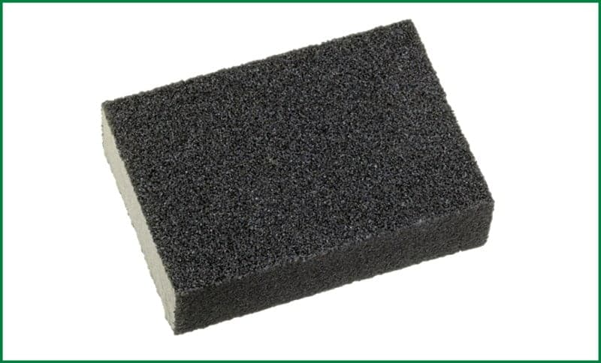
A sanding block is a sandpaper holding device. It is one of the most basic woodworking tools. The typical sanding block is square in shape, but the structure and shape changes based on usability. Woodworkers normally make it with wood. The block with sandpaper on it helps to remove the rough grains from the wood surface to make the layer smooth.

Yesterday I lost 100 sheets of sandpaper...
but I have a rough idea where they are

Alan
Brian Glen
Andrew Grant
Herman Allan Graham
Dale John Ian Peter Trevor
Ansi George Wayne Paul Vince
Ben Graeme Jim Mat Ross Joe Bert
Jeff Bruce Gary Don Ray Tony Phil Michael
Bill Geoff Frank Bob Kevin Laurie Lyndon Rob
Dick Craig Dave Rod Shane Tim Ron Mark Russell David Angelo Stan Des
Coffee
Scones
NEW MEMBER PROFILE 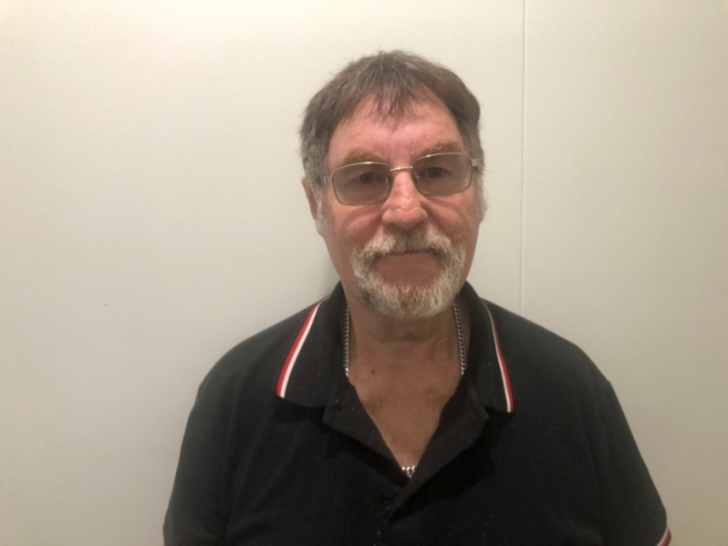John Kirby spent 12 years in the RAAF and did one tour of Vietnam. He grew up in Maidstone, Victoria, is married with a son and 2 grandchildren. John loves working with wood and creating things. He follows Richmond in AFL and is looking forward to friendship and having a good laugh with everyone at the shed.

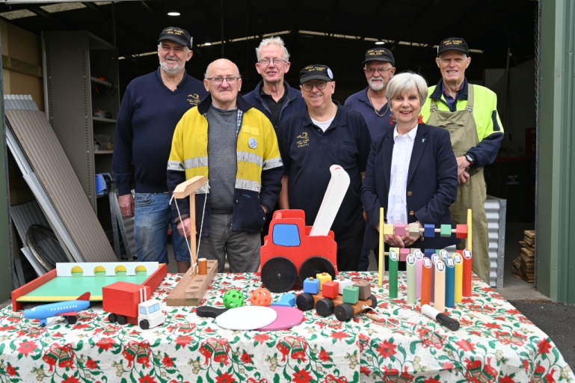
Peter, George, Jim, Shane, Gary and Ian spent hundreds of hours crafting 130 handmade wooden toys to donate to the 2023 Mount Gambier Community Mayor's Christmas Appeal. Mayor Lynette Martin accepted the toys at the shed and thanked the volunteers for their contribution. Over the past seven years the volunteers have made 1000 toys for children in our community.
Used with permission Mt Gambier City Council

My mate built himself a motorbike.
It's got a wooden frame, wooden engine, wooden wheels, and a wooden gas tank.
Did he ride it?
No, it wooden start!

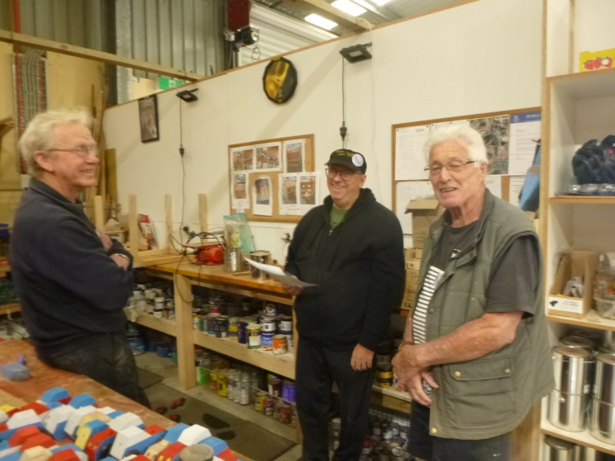
In the toy shop – Jim, Shane & Graham

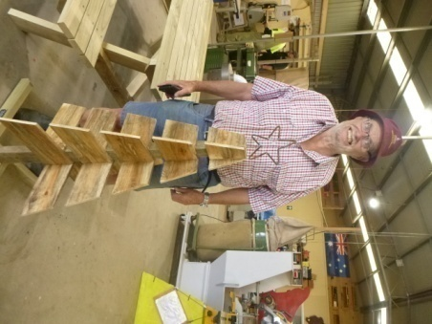 | 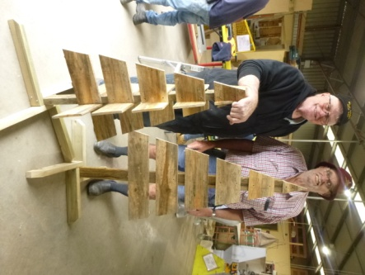

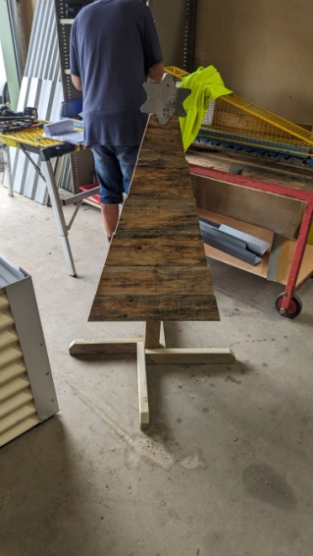 | Top left – Jeff with Christmas tree, star made by Trevor  Top right – Grant and Jeff  Left – original design by Jeff  
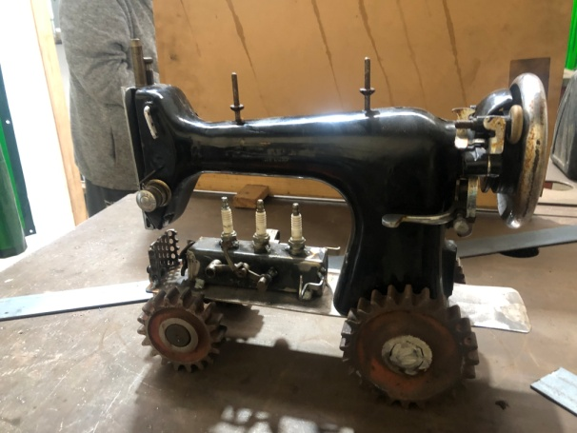
Ians finished tractor
HEAD TO HEALTH
A new Federal government initiative has just opened in Mt Gambier. It is a free, walk in MENTAL HEALTH service located at 7/165 Commercial Street, open Monday to Friday 9am to 5pm
Finding the right services for you can be hard. Head to Health is here to help you find and access services that meet your needs – including free and low cost mental health services where appropriate. This service is available to all adults living in Mount Gambier who may be experiencing distress or mental ill health, and their families, carers or support networks.
Call 1800 595 212 or go to your local centre.

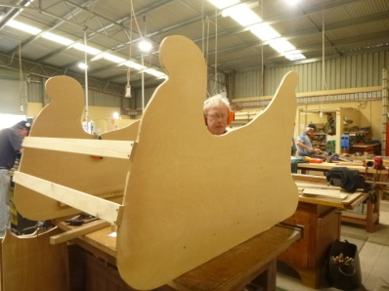
Is that Santa’s helper
in the sleigh?
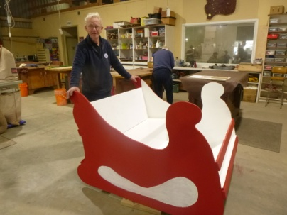
Jim – one of the team who constructed a sleigh for Mulga Street Primary School

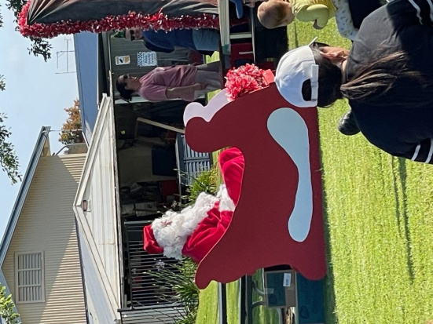
Santa in the sleigh at Mulga Street Primary School



“I just got new hearing aids” Fred boasted, “they’re absolutely fabulous.

I can even hear the plane shaving the wood.”

“that’s wonderful,” said Bill, “what brand are they?”

“about four o’clock.” said Fred
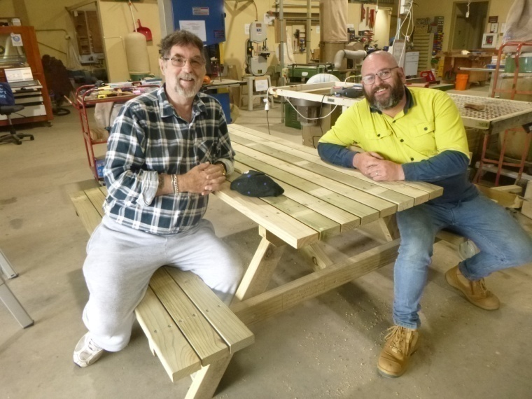
Another picnic table ready to go out the door – John & Mark
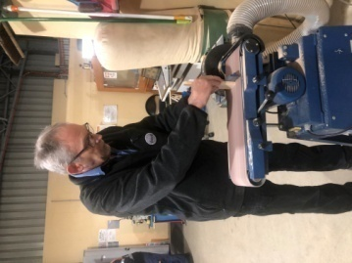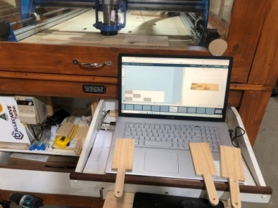
Above left - David sanding Gnocchi boards designed on computer and made on CNC machine above
Left – box of finished gnocchi boards with CNC laser engraving.
Well done David.
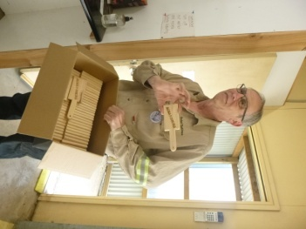
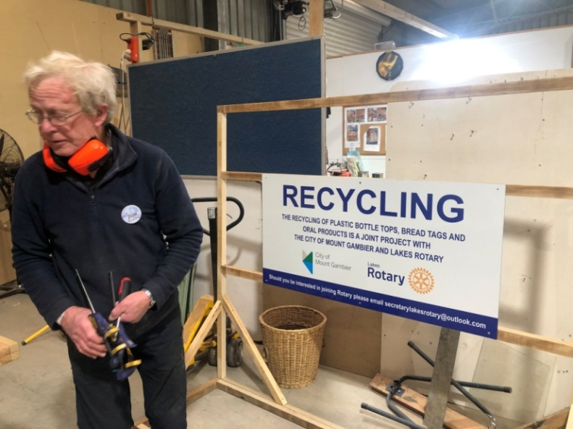
Jim - Check out the finished project at Woolies Marketplace
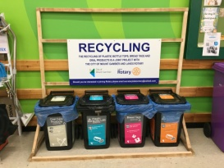
I tried to recycle a broken pencil . . .
but it was pointless!

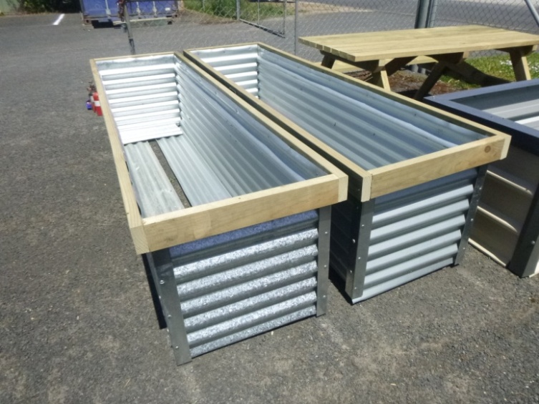
An improved design & finish on raised garden bed design
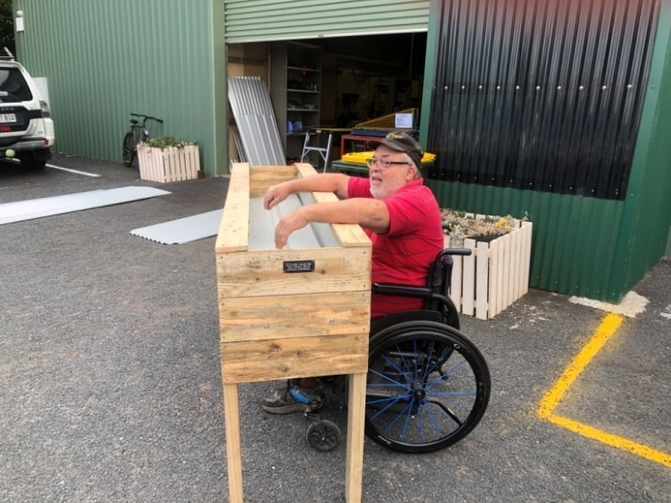
Laurie with wheelchair friendly raised garden bed

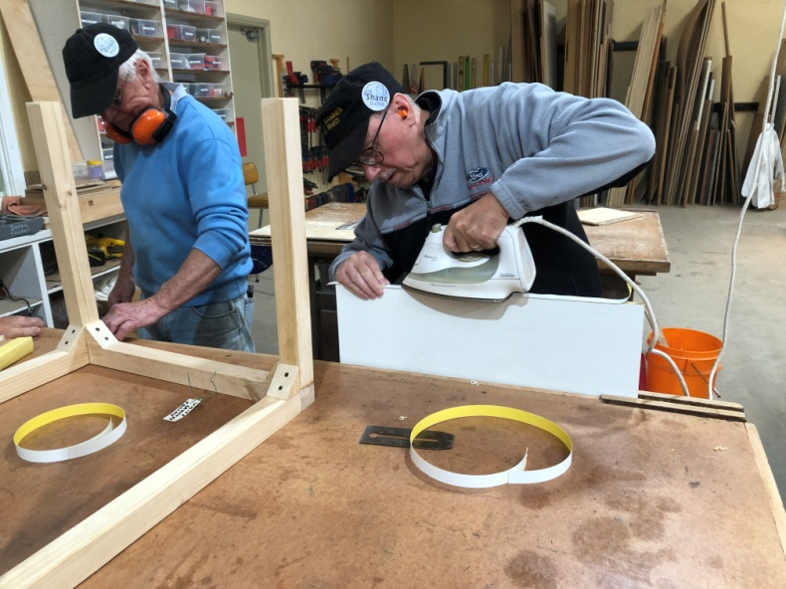
Is it true Stratty does the ironing at home?

Don’t be irreplaceable . . .
if you can’t be replaced,
you can’t be promoted.
It is far more impressive when others discover your good qualities . . .
without your help
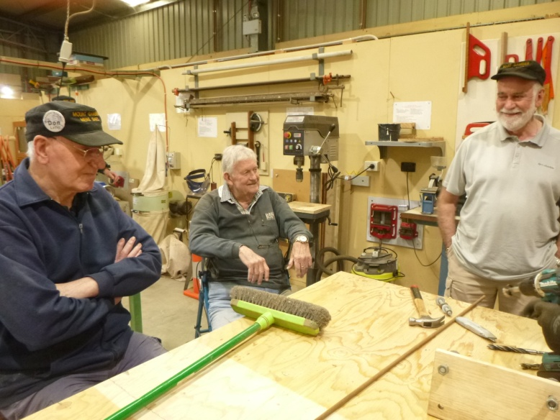
“How do you start the broom?” Don, Ian & Rob
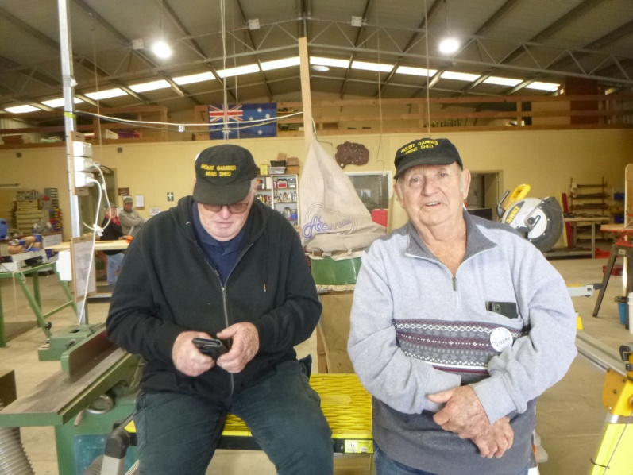
Caught on the hop – Grant & Graeme
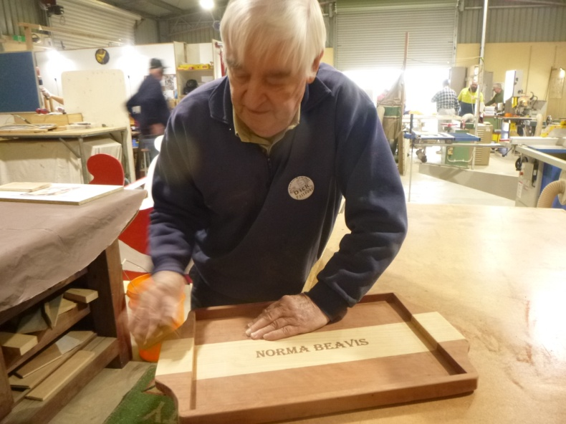
Dick with one of his embossed serving trays
oregon, pine & red gum
‘BARRY DAY’
Towards the end of each year, our Shed remembers and celebrates the lives of those Shedders who are no longer with us. This is called ‘Barry Day’
Barry Tuffnell was our first Shedder to die. We recognise all who have passed away and those who can no longer attend due to health conditions of themselves or their partners.
There is a photographic display of all these men on a Shed wall so that newer Shedders can refer to images of those we remember and talk about.
This year we invited all partners of these Shedders to join us in a BBQ lunch together with our own partners.

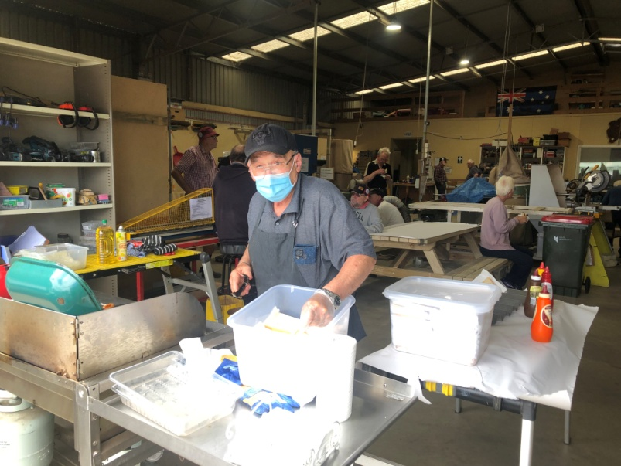
Ben at the BBQ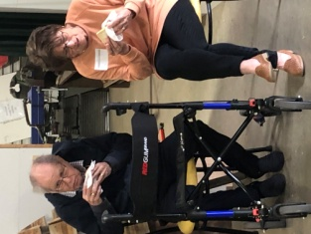Everyone enjoyed the sausages,onions and delicious biscuits

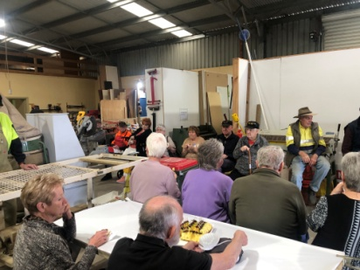
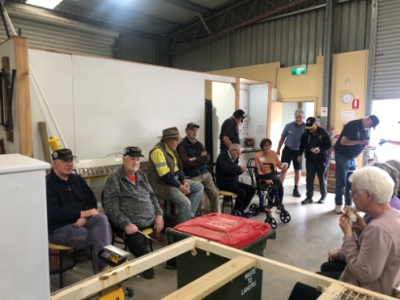
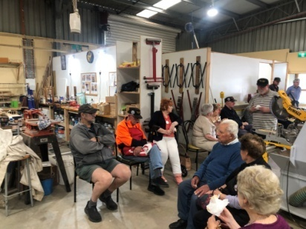
Partners appreciated the food, hospitality, meeting shedders and the opportunity to see where all the work (??) and talking happens.
Barry Day continued . . .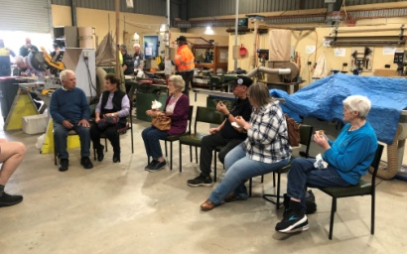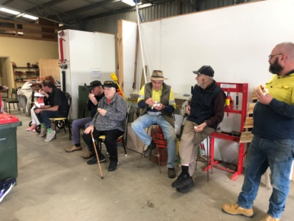

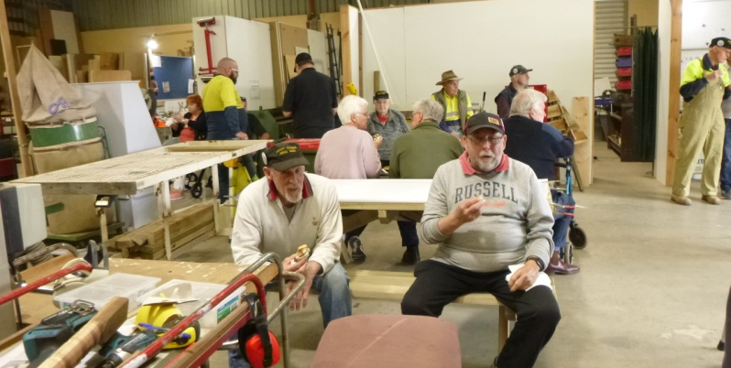

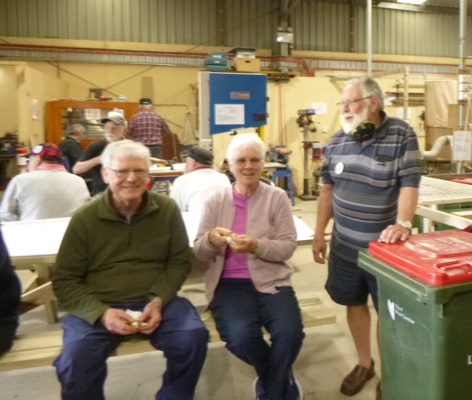
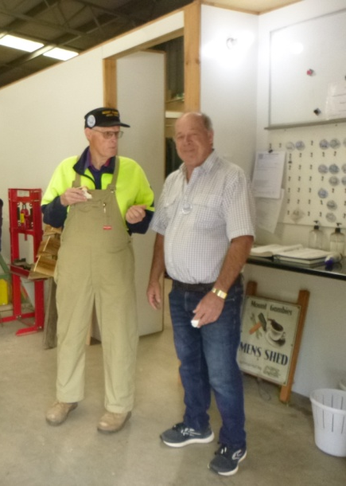

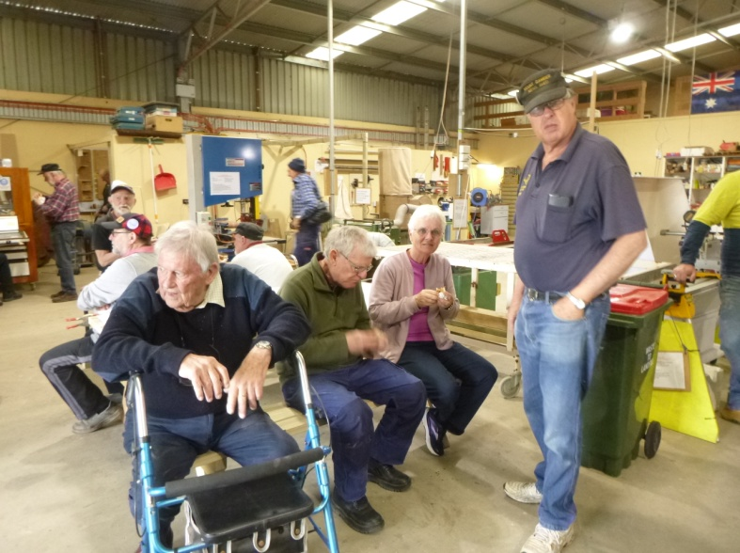

Barry Day - what a great way to recognise and remember past members.

A man and his wife had a shed in their backyard. The neighbour asked which of them built it and they both replied that they had built it, leading to a massive argument. It was a real He-Shed She-Shed situation.


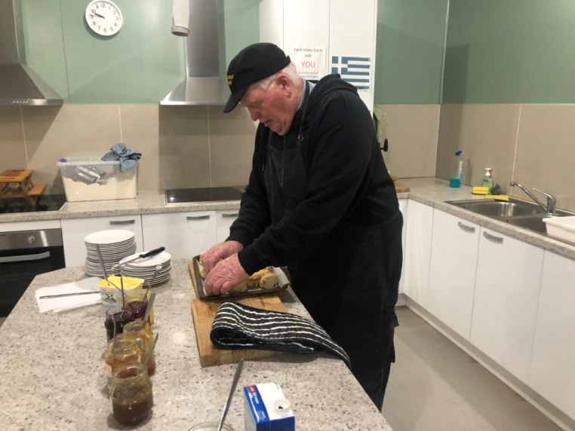
Grant perfecting his scone making skills
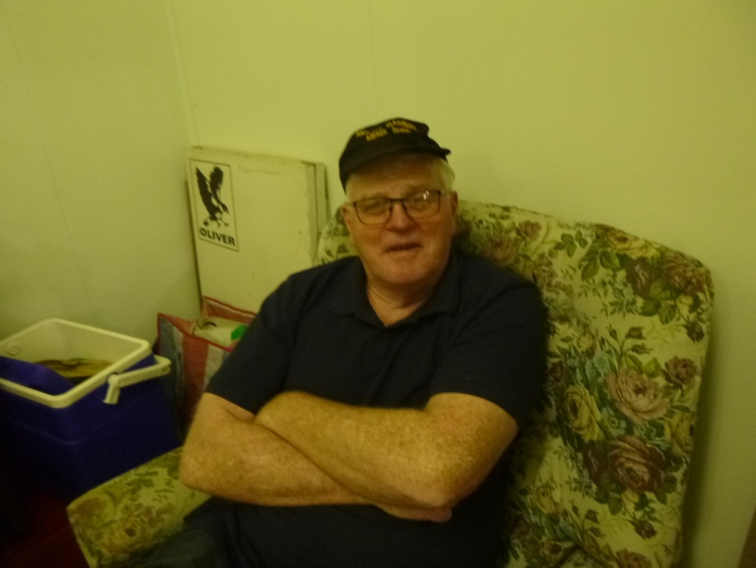
Grant perfecting his relaxing skills
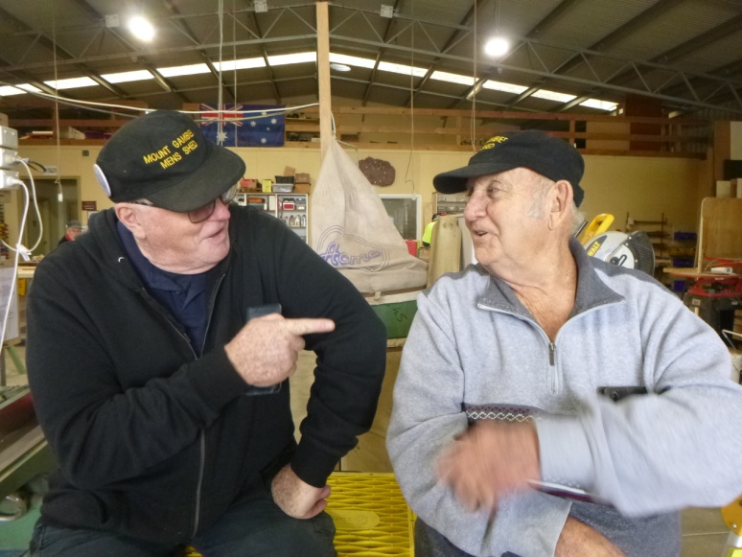
Grant all refreshed and ready for discussion with coffee maker Graeme – doesn’t Graeme know how to make coffee by now?

You cannot force someone to comprehend a message that they are not ready to receive.
Still, you must never underestimate
the power of planting a seed.
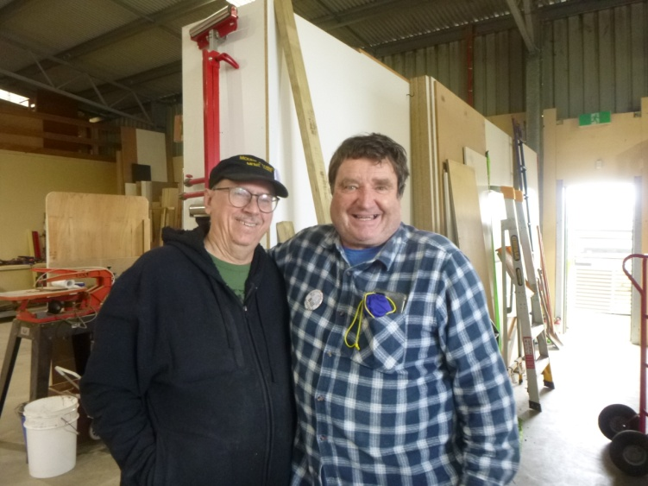
Great mates – Shane & Bill
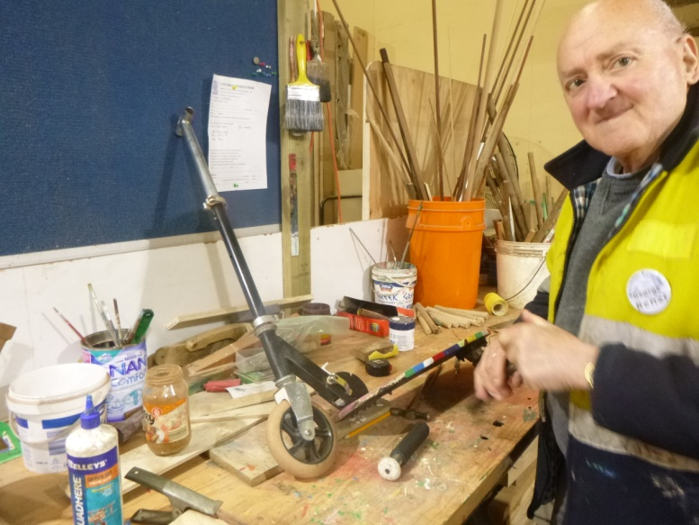
George repairing a scooter
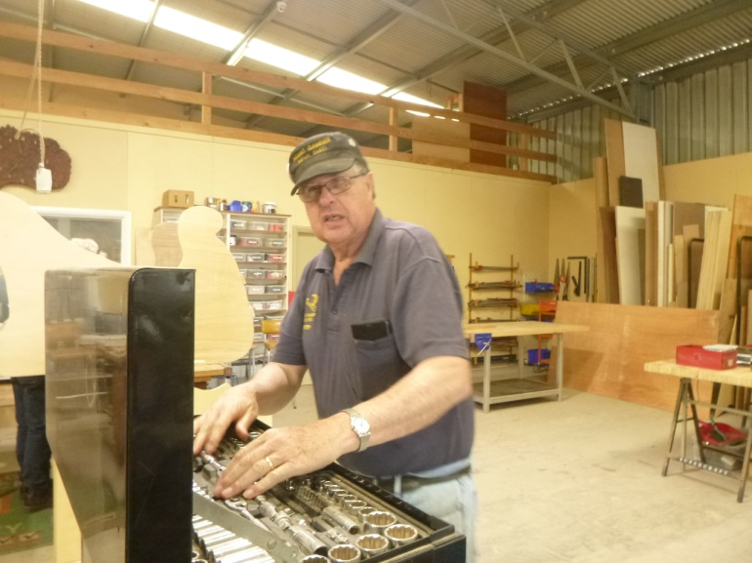
“You can’t hand a man a grander spanner than a Sidchrome”
Peter


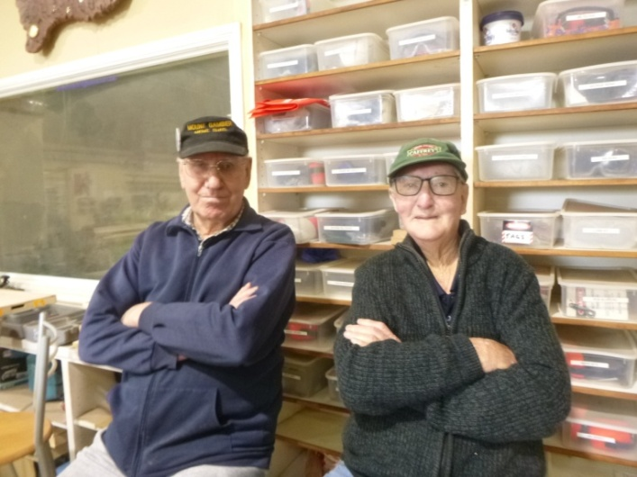
Don & Alan relaxing or are they pretending to be supervisors?

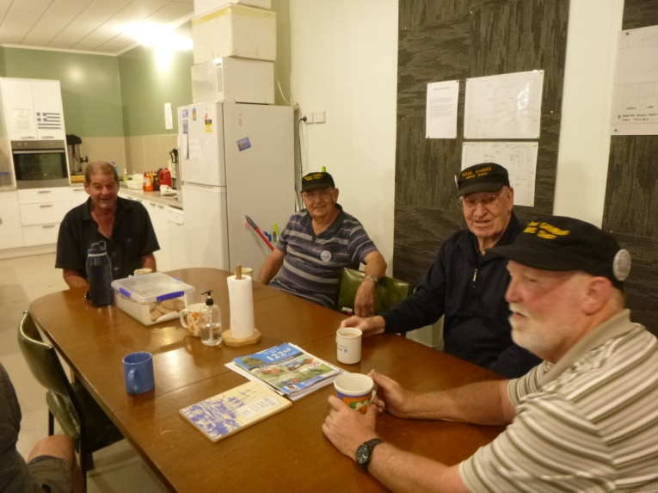
Morning chat – Trevor, Graeme, Don & Kevin
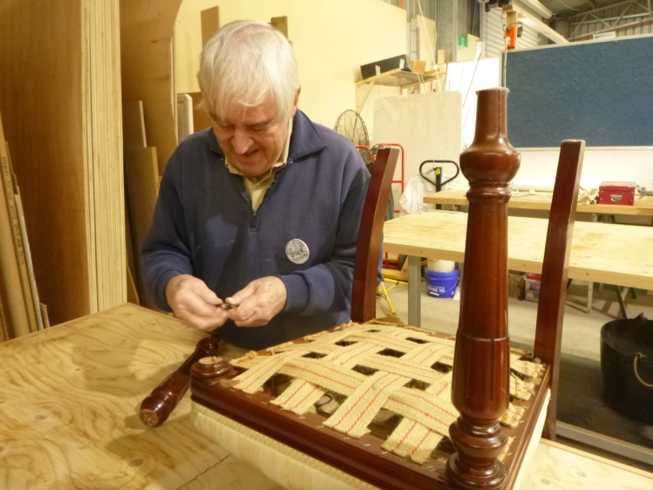
Dick mending broken chair leg

Before you criticise someone, you should walk a mile in their shoes . . . that way, when you criticise them, you are a mile away and you have their shoes.
SPONSORS










Big supporters of Mount Gambier Mens Shed

SUPPORT OUR LOCAL BUSINESSES
THAT SUPPORT YOU

