mgmensshed@gmail.com
EXECUTIVE MEMBERS FOR 2021
PRESIDENT: Peter Halleday 0439500699
VICE PRESIDENT: Ian Bond
TREASURER: John Plunket
SECRETARY: Paul Edgeworth 0887256385
PHONE: 0478614027
FACEBOOK Mens Shed Mount Gambier
Shed broadcasts are now available on Facebook

Safety: - Remember Safety begins at home.
BIRTHDAYS
Allan V 01/10
John P 02/10
Laurie T 10/10
Peter H 14/10
Bruce A 24/10
Trevor T 24/10

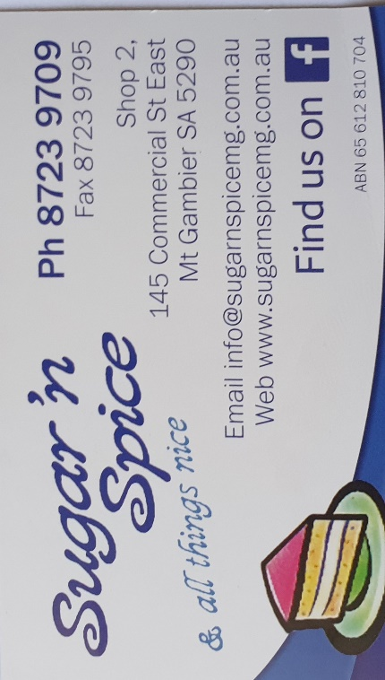
Remember Sugar ‘n Spice support our Men’s Shed with Birthday cakes, so support them where you can.
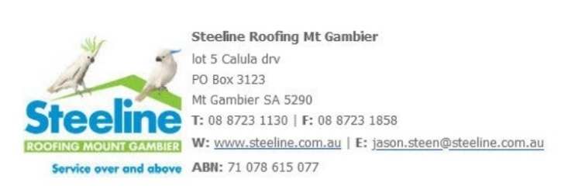


Thanks to Sharp Cranes and Steeline for supporting our Mens Shed.


Big supporters of Mount Gambier Mens Shed.
SUPPORT YOUR LOCAL BUSINESSES
THAT SUPPORT YOU.
For anyone wishing for more Mental Health help check out this site and see what they have to offer.
Phone: 04-77886450
www.thesoutheastjunction.org.au

 thesejunction
DIARY DATES: 2021
1st October Friday evening Pen Press fundraiser for the Shed at South Aussie Hotel
2nd October Saturday 8.30/12.00 Bunnings BBQ
10th October World Mental Health Day.
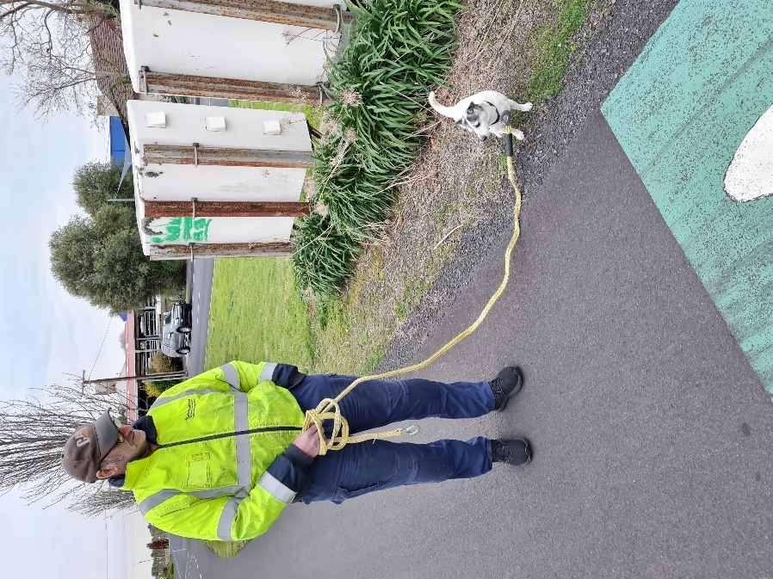
Although not Shed related had to put this on as everyone knows Dave’s dog Toby. Felt sorry for the poor little boy as Dave forgot to bring his lead for walking so he had to go with the heavy tow rope.
JOKES:-


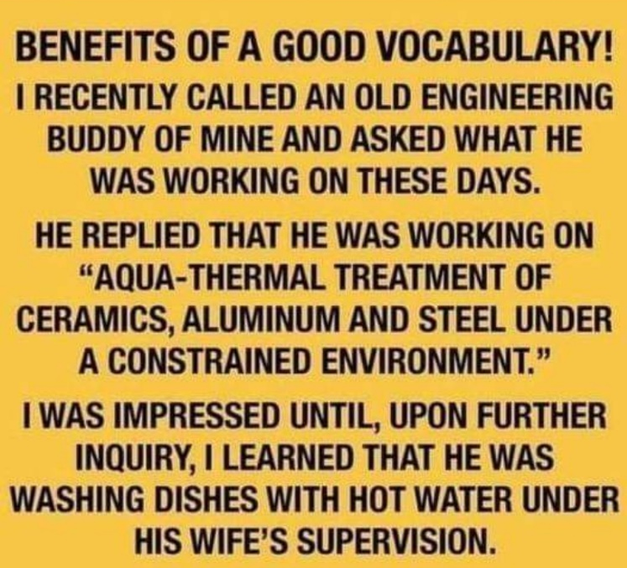
Think of this next time you do the dishes fellows.
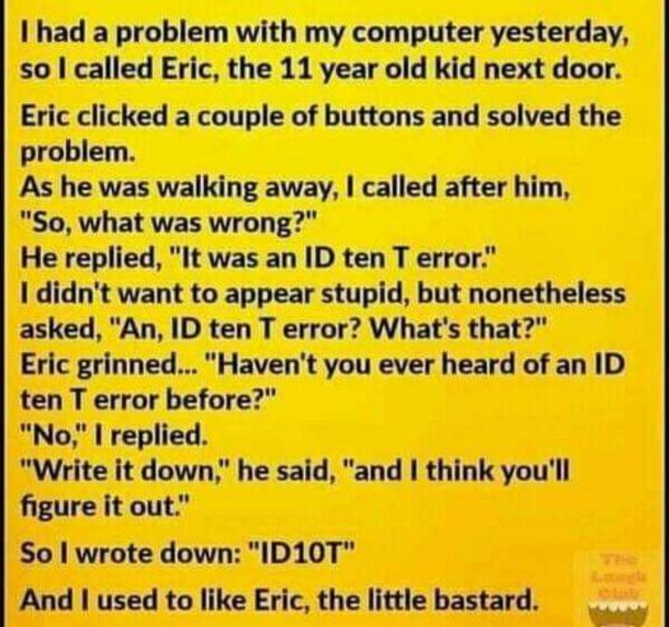
We recently had a NEIGHBOUR CALL THE LOCAL Council office to request the removal of the DEER CROSSING sign on the road. When asked the reason why she replied too many deer were being hit by cars and it was not a good place for them to be crossing anymore.
Women went to a Mexican Taco shop and asked for minimal lettuce on her Taco She was told sorry we only have Iceberg lettuce.
Last trip overseas at the airport I was asked if anyone had put anything in my bag I did not know about? To which I replied if I did not know how would I know the answer? They smiled knowingly and said that’s why we ask.
The Pedestrian light on the corner beeps when it is safe to cross the street. I was crossing with a Co Worker and they asked if I knew what the beeping was for. I explained it was for blind people to signal when the light was red. Appalled they responded “what on earth are blind people doing driving. They are a government worker.
When my wife and I arrived to pick up our car after a service we were told the keys were locked inside. We went to the service department to see the Mechanic working feverishly trying to unlock the door on the driver’s side. As I watched from the passenger side I instinctively tried the door handle and discovered it open. “Hey I said to the technician, it’s open!” His reply was “I already did that side.”
These people walk amongst us so be careful and stay alert
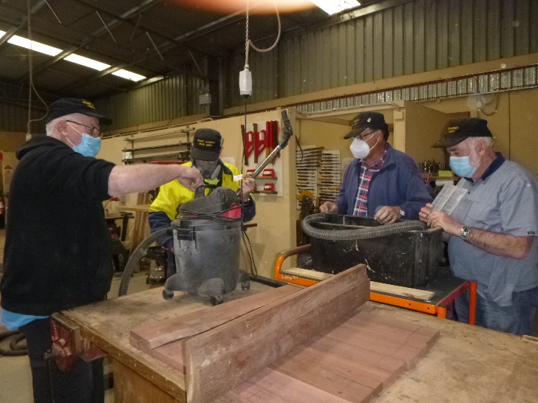
Apparently it appears that some men do not know how a vacuum cleaner works so Grant is showing them the basic fundamentals of one.
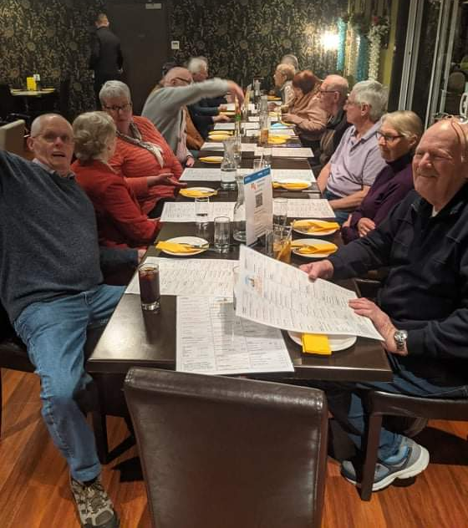
September meal at the Thai resturant top and below.
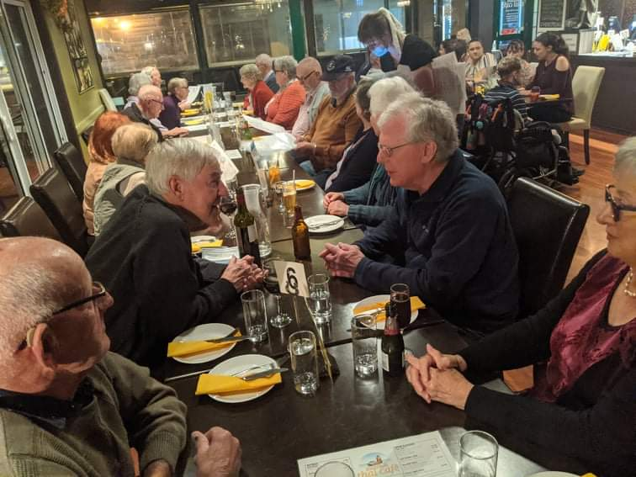
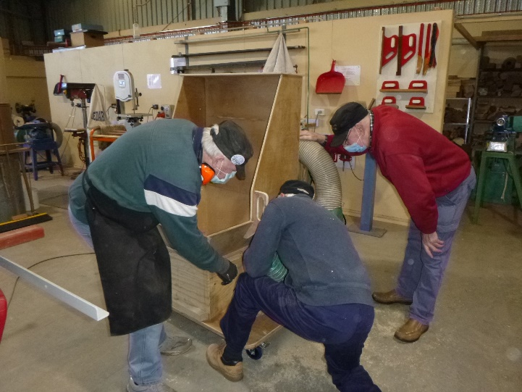
Don C and Allen fitting the dust catcher for the drop saw while Don L watches on.
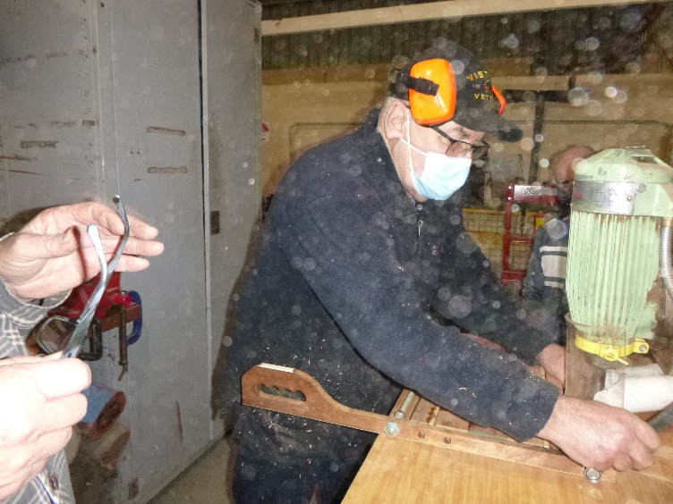
For all those that know about earmuffs, this is not how Ansi would normally use them when on the router!!
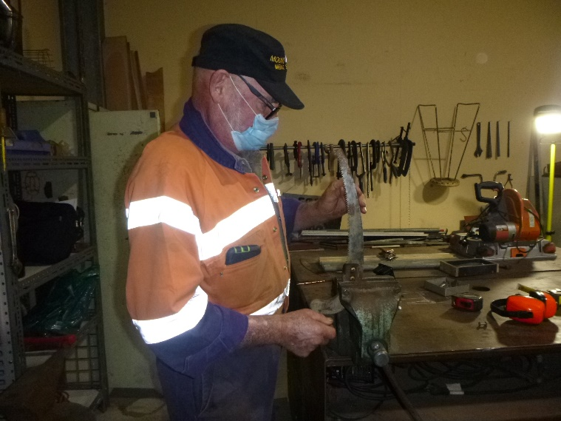
Bruce showing how he sharpens a saw. 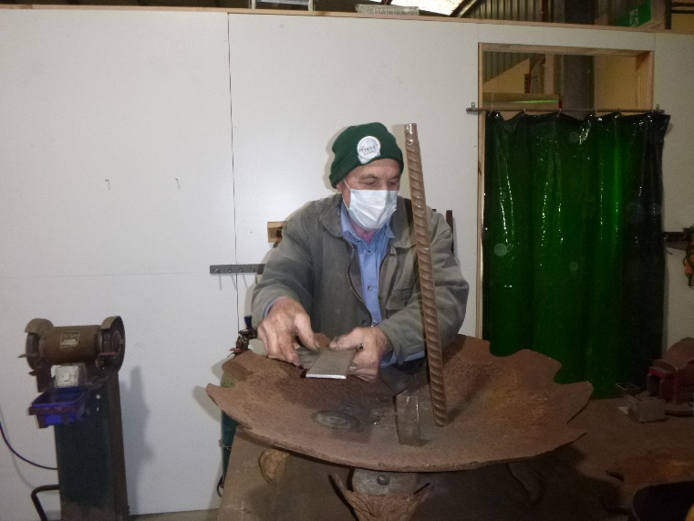
Trevor working on his 3 tier water fountain.
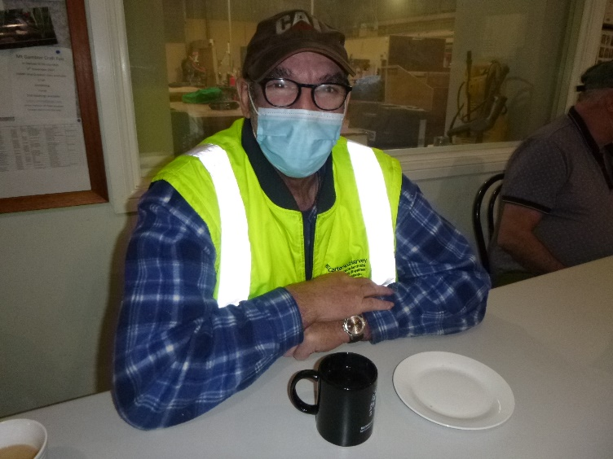
Everyone says Dave never stops working. Well we finally caught him having a Cuppa. 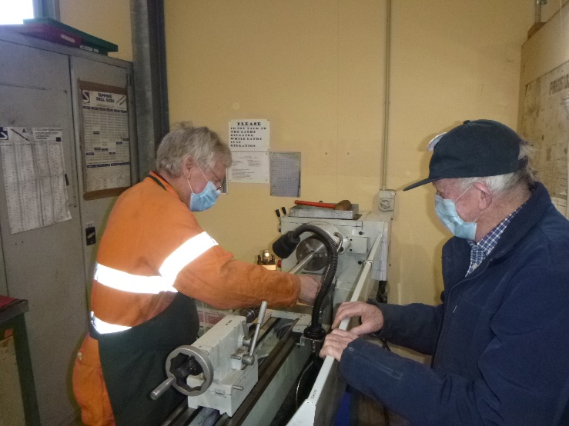
Jim turning some Galv pipe. 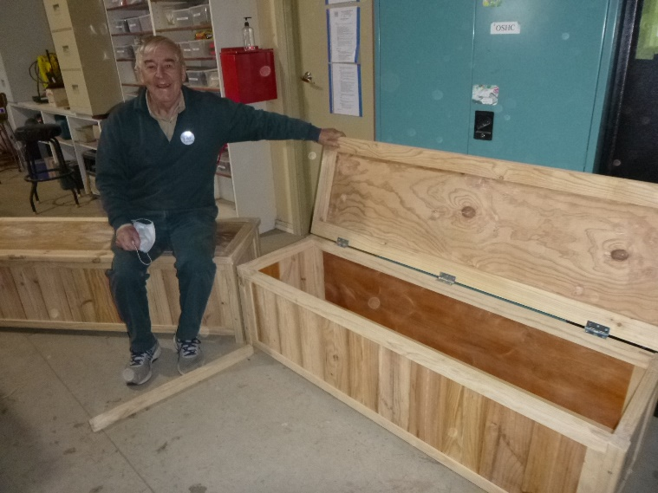
Dick very proud of the 2 boot boxes he has made.
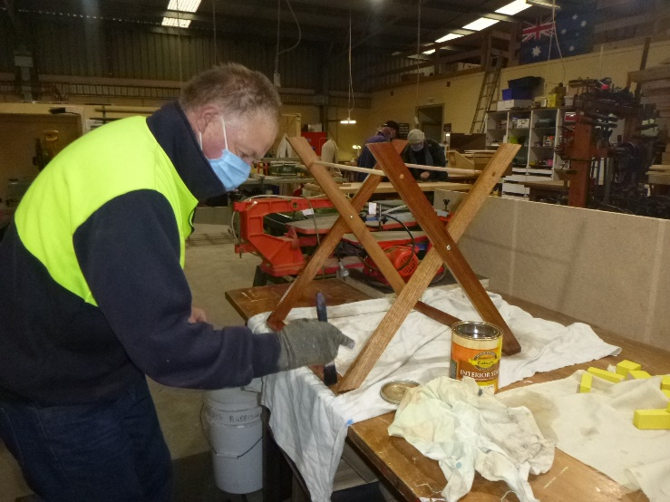
Gary and George working on toy clothes lines.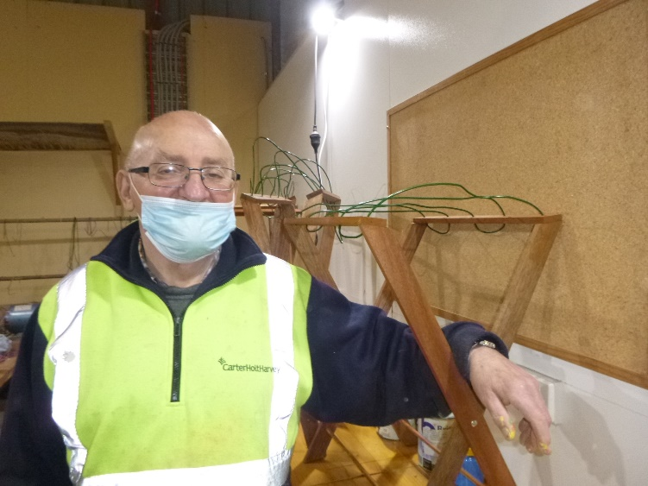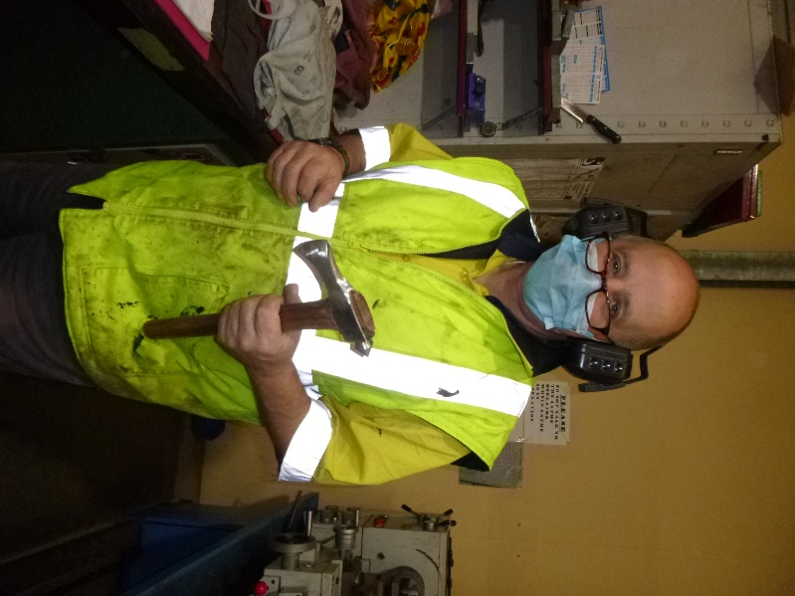
Ian with his hand made axe.
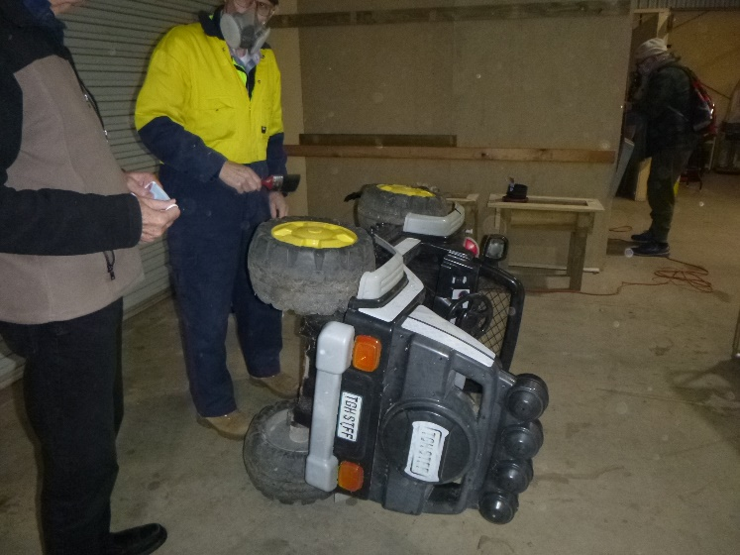
Ian checking out if the old car can be repaired. Unfortunately, no, well past it’s Rego date and won’t work anymore.
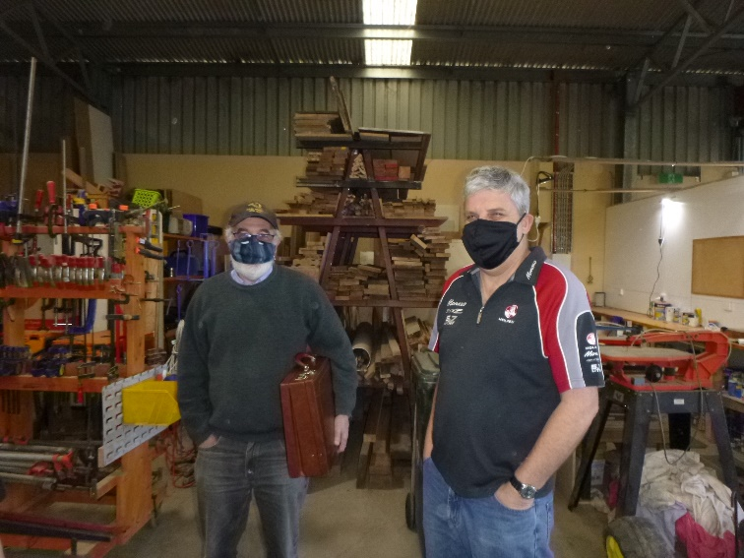
Long-time no see each other, so John and Tony having a catch up.
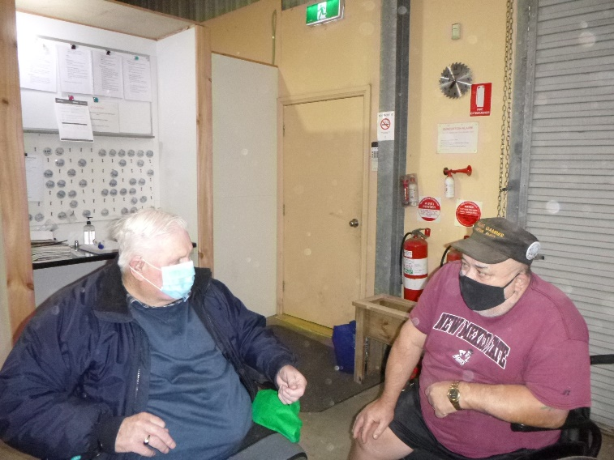Kevin and Laurie conjuring up something, probably a wheel chair race with each other.
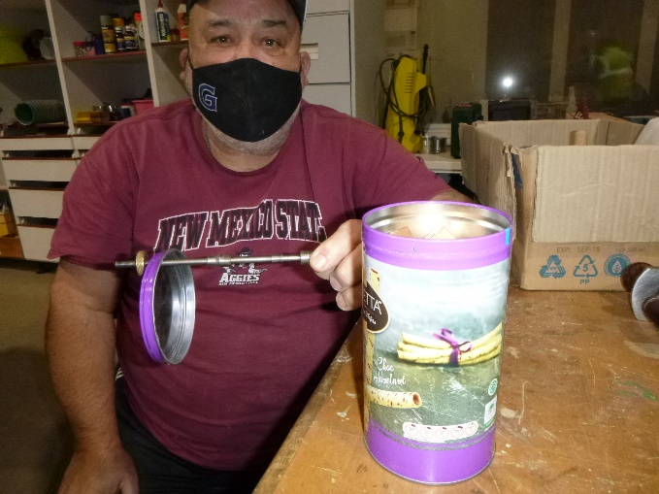
Laurie with a tin full of pen making tools.
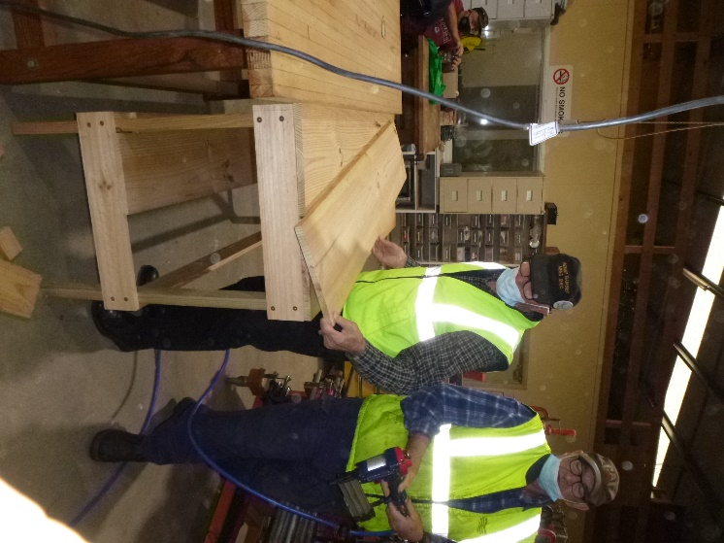
Ray and Dave working on an outdoor garden table for Ray’s wife.
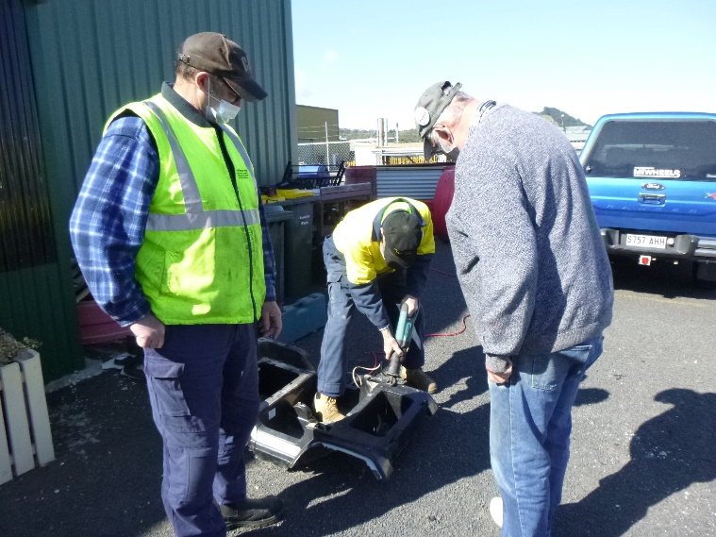
One worker and 2 overseers. Dave and Peter watching Ian working.

Next is a few of the things we make at the shed that are for sale
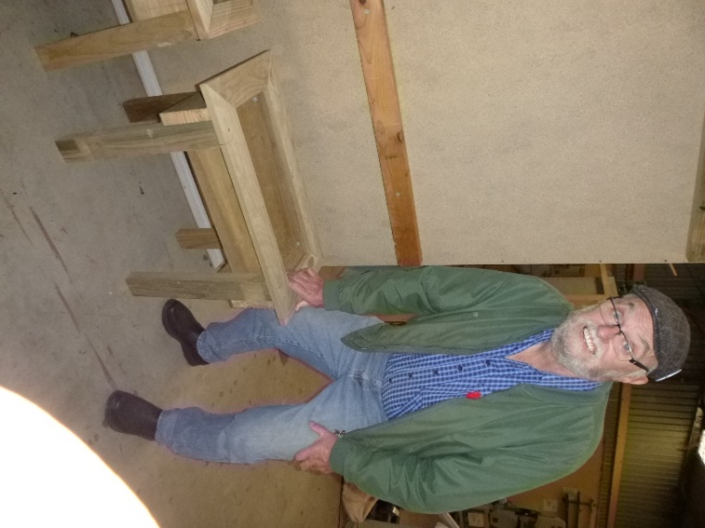
Planter Box.
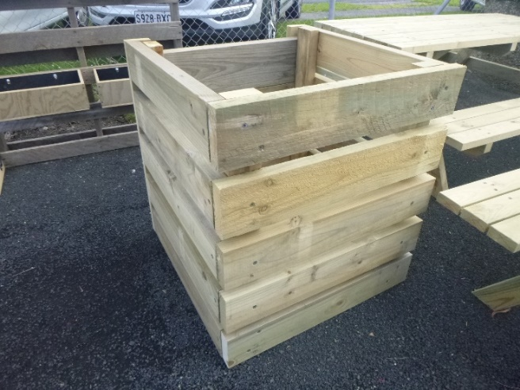
Compost bin.
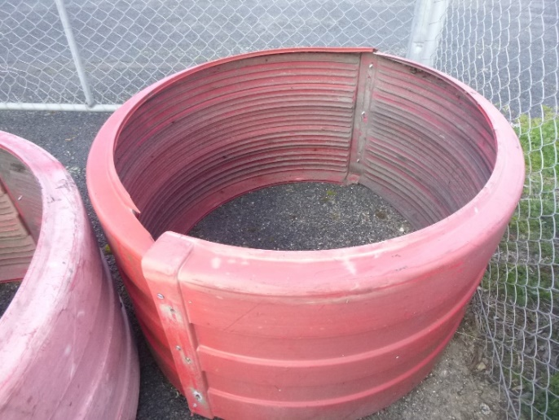
Small round raised garden bed.
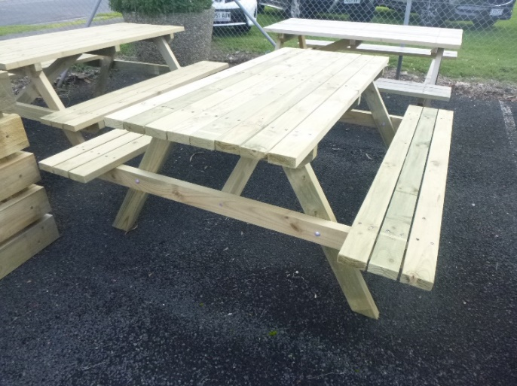
Picnic Table.
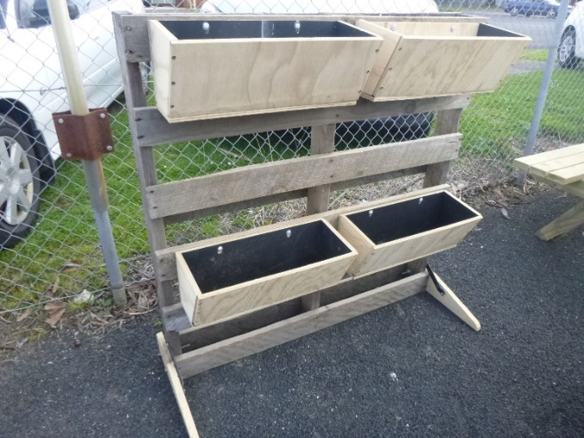
Wall planter boxes.
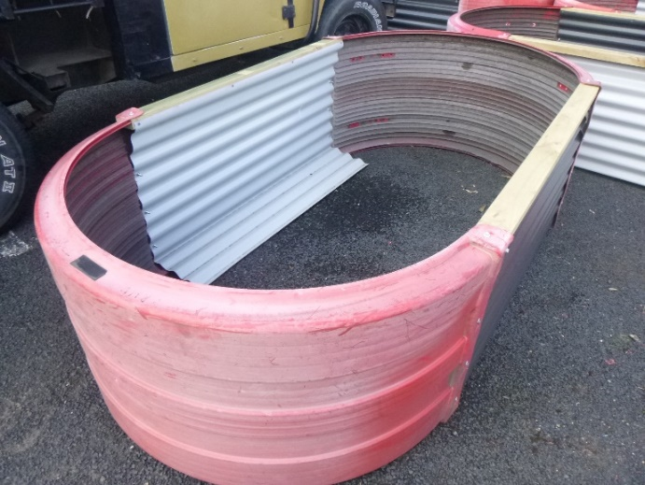
Large raised garden bed.
Contact the shed for details.
PHONE: 0478614027
FACEBOOK Mens Shed Mount Gambier

