EXECUTIVE MEMBERS FOR 2023
PRESIDENT: Ian Bond 0420 859 540
VICE PRESIDENT: Grant Sullivan
TREASURER: John Plunkett
SECRETARY: Paul Edgeworth 0497 386 846
PHONE: 0478 614 027 (prefer Tuesday and Thursday am)
Open Tuesday, Wednesday & Thursday 9am – 12pm 1a McDonnell Drive
Website www.mgmensshed.com.au
Facebook Mens Shed Mount Gambier
Email mgmensshed@gmail.com

BIRTHDAYS
David H 02/08
David B 04/08
Don C 05/08
Peter B 06/08
Paul E 07/08
Gary V 13/08
Don L 14/08
Rob B 23/08
Kevin P 23/08
Frank Mc A 23/08
CALENDAR - August
Sunday 6th Bunnings BBQ
Wednesday 9th 6.30 Shedder & partners tea at Blue Lake Golf Bistro
Thursday 10th 10.30 Members Meeting
Thursday 17th Continence & Prostate Cancer-speaker
Thursday 22nd 10.30 Committee Meeting
Thursday 31st BBQ lunch
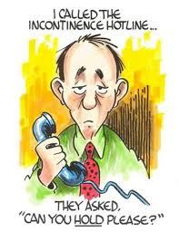

**********
If you would like to contribute information or an article to your newsletter, talk to Editor David N or email mgmensshed@gmail.com

7. Centre Punch
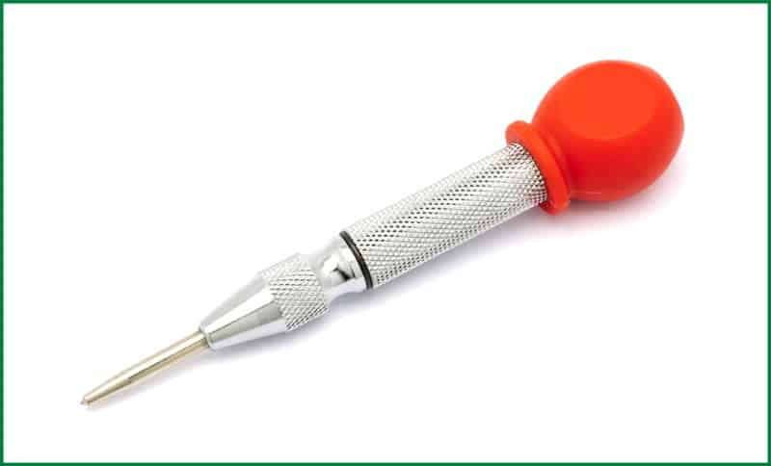
Punch is a tool made of metal with a pointed fine tip. The handle of the tool is usually broad and rounded to facilitate hammering. An iron hammer or wooden mallet is used to strike on the broad handle to insert the pointed edge on the targeted object.
This tool can be of varying types based on their purpose. Each of them has its specific structure and properties complementing its purpose. There are drift punch, centre punch, prick punch, decorative punch, transfer punch, letter punch and others.

Uses of Centre Punch
The punch tool is used by woodworkers to mark the centre to assist in drilling. It is also used for duplicating patterns of markings on different pieces. The letter punches are quite impressive in their work. They are used for engraving letters or numbers on wood pieces.
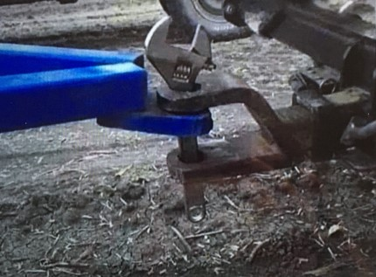
Tools have many uses, not all are recommended!
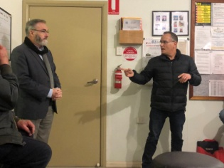
Well, what a great session from David and Claude demonstrating their Tesla and BYD (Build Your Dreams) cars.
Those that thought they knew everything learnt something extra and those that knew a little bit were brought up to date and had their eyes opened to the amazing limitations and future possibilities.
Myths were politely quashed and the history, politics and future of the motor industry were expertly put into context.
Environmental benefits for the planet and general health improvement was laid out.
To finish our inspection of the features, the Tesla actually put on a party (lights flashing to music). Wow!! Dick P
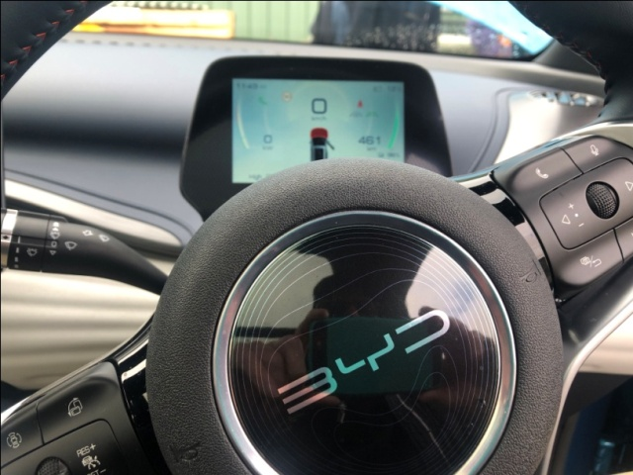
BYD dash
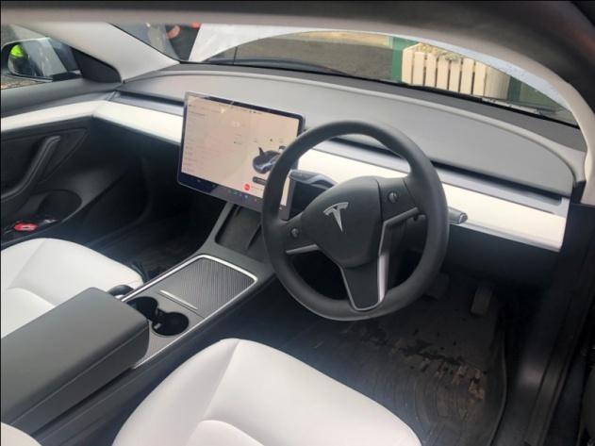
Tesla dash
HIRED A HANDY MAN AND GAVE HIM A LIST.
WHEN I GOT HOME, ONLY #1, 3 & 5 WERE DONE.
TURNS OUT, HE ONLY DOES ODD JOBS!

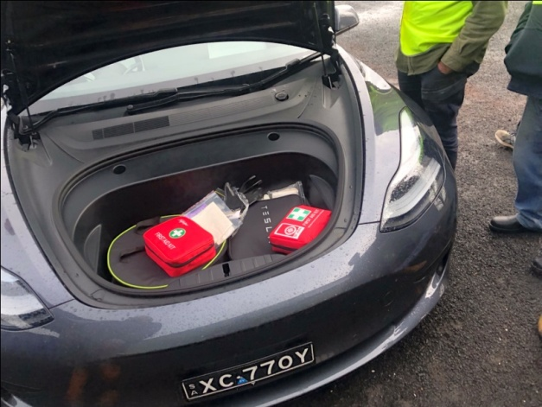
Tesla – under bonnet
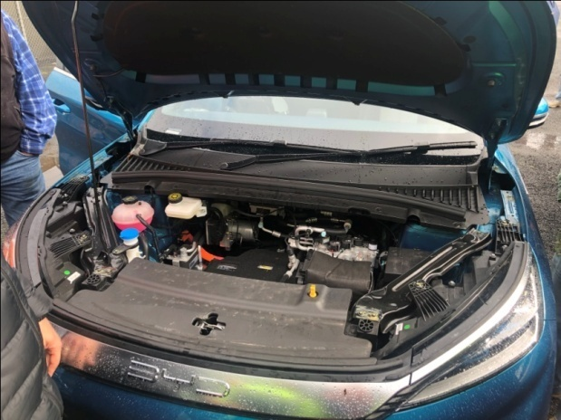
BYD – under bonnet

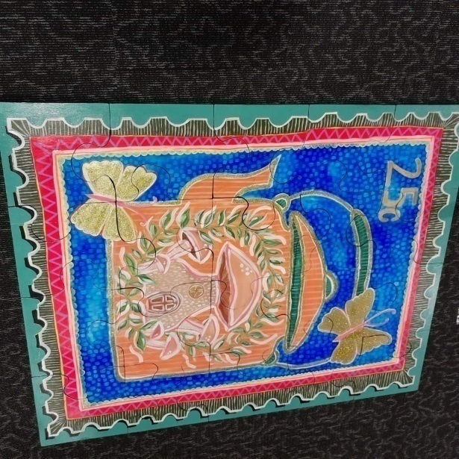
Finished floor jigsaw at Riddoch Art Gallery
As with all Mens Sheds, we have our share of men in the process of receiving treatment or recovering from sickness. Some men struggle with life , Mens Sheds provide a safe place to share and to know they are not alone.
On a happy note, one of the highlights of recent times was when the president’s bell was sabotaged and would not ring when he
tried to call the group to order for a meeting. Grant S

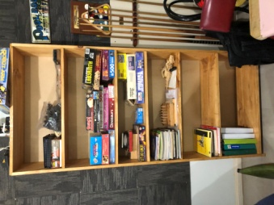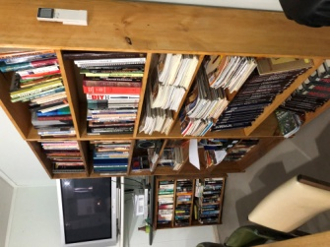
3 tall bookshelves made by Dick P & Ray L
have been put to good use in the smoko room
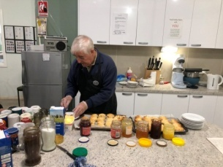
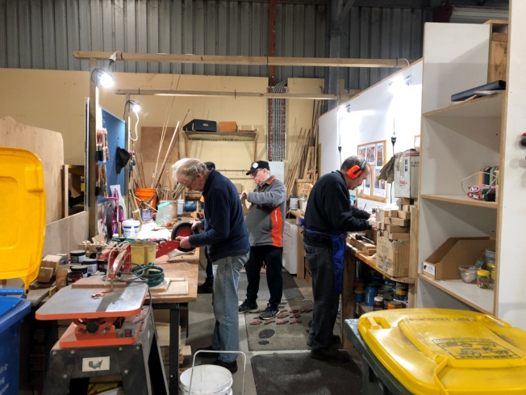
Toy Boys appreciate room to move without bumping into each other – much safer!
Below - Finished toys in storage container
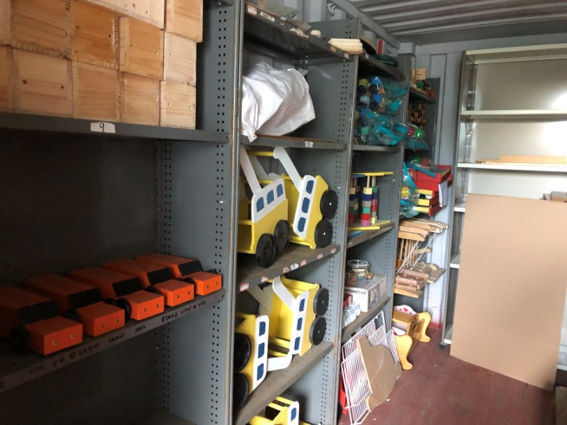
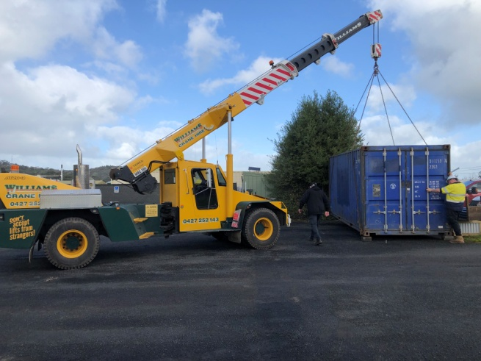
New storage container being placed at front fence
by Williams Cranes
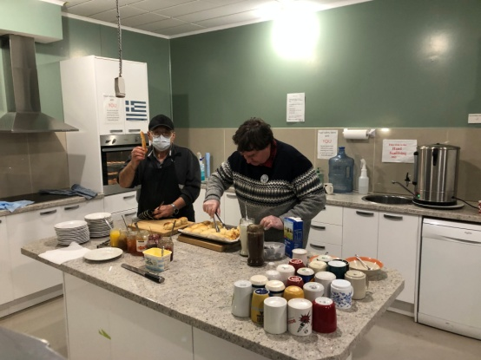
Ben K & Bill McG making scones
Below - Thanks to Dick P & Grant S - scone making apprentices in Ben’s absence
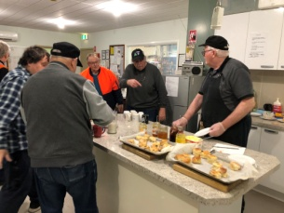

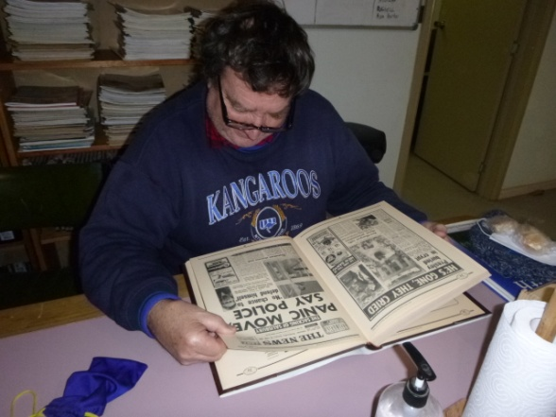
Bill McG catches up on some history reading
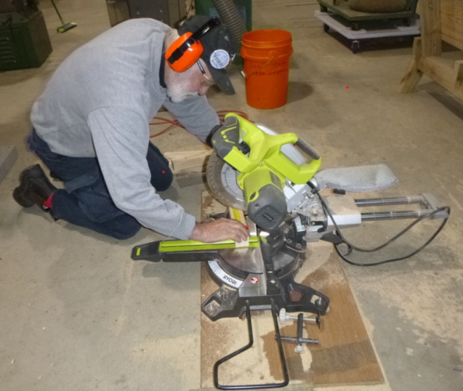
“How low does one have to get to cut a piece of timber” says Herman B

Visitor of the month – Ron Irwin from Wingham Mens Shed NSW

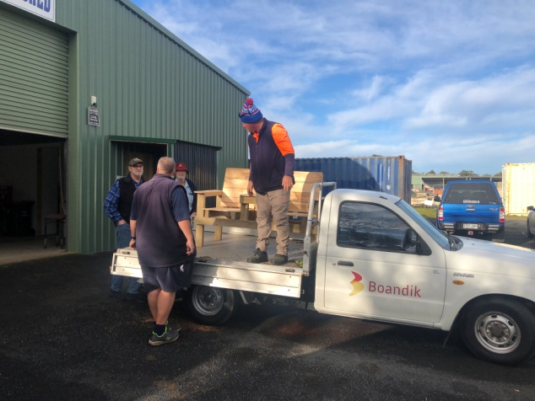
Boandik collecting Jack & Jill seat made by the team who make picnic tables & garden beds. Painted version below
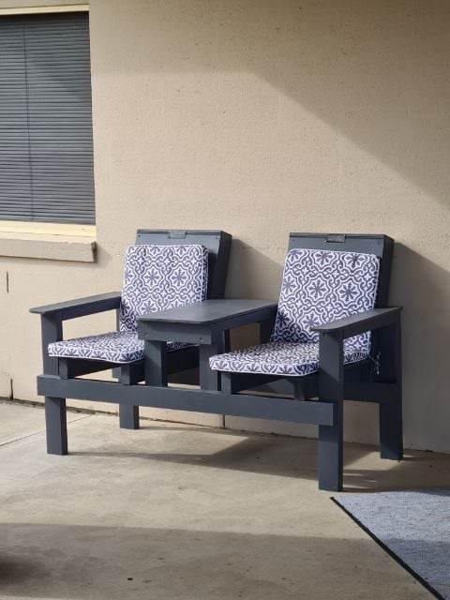

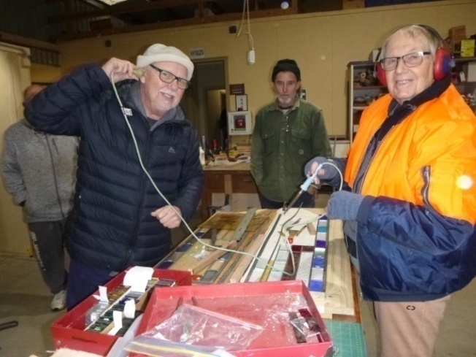
Mat J “tunes into” Graham T’s leadlighting soldering while Ron P watches on
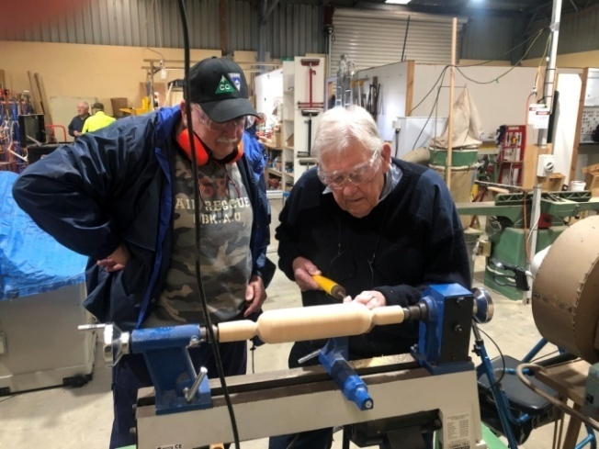
John S & Ian L turning a rolling pin
“the blind leading the blind” - under supervision

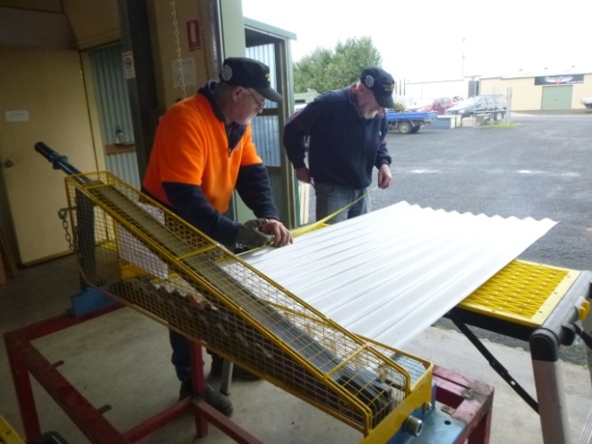
Gary A & Frank McA prepare garden bed iron
for guillotining
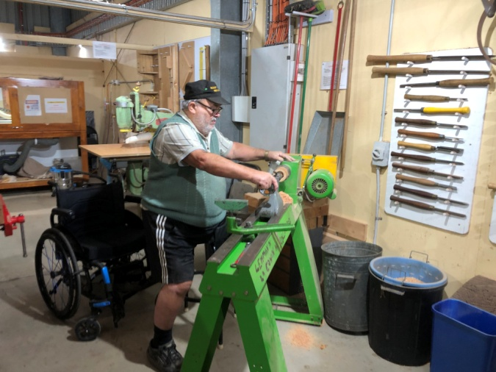
Laurie T at the wood lathe
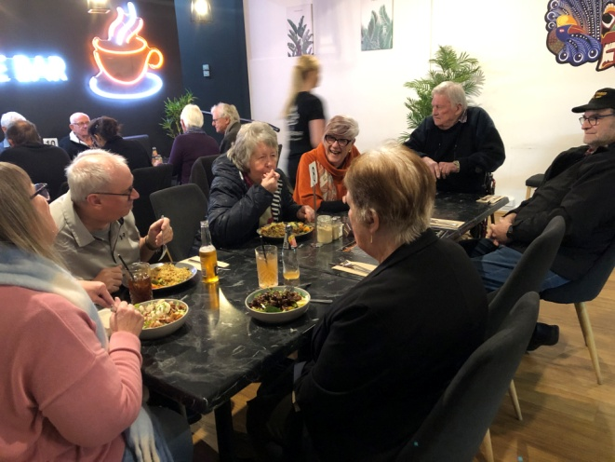
Above & below – Shedders tea at Foodie Bar
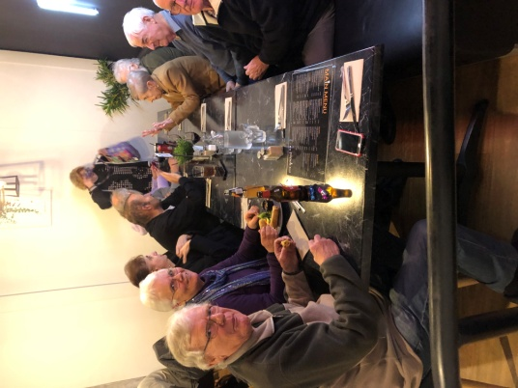
HEYWOOD’S MENS SHED - MENS HEALTH
On 27th July, Rod B, Ron P and Russell S went with Paul E to Heywood for a get together with about 40 other Men’s Shed people for talks on men’s health. There were several guest speakers on various topics of men’s health. Two of the speakers spoke on their dealings with BLACK DOG mental health. They spoke of how they handled it; they were told they would never work again and with determination and strong will they are now back in the work force. Another speaker spoke on NUTRITION and the benefits of the Mediterranean Diet, package labelling and what is really in packaged food. She suggested we should consume at least tablespoon of Virgin Olive Oil every day.
A balanced diet is very important.
Also an Ambulance Officer spoke on CPR and Defibrillators and demonstrated their use. He said every minute means success or not; just hop in and do your best.
The Heywood Shed provided their usual great hospitality and a lovely three course meal. Thanks to Paul for driving us over. Rod L
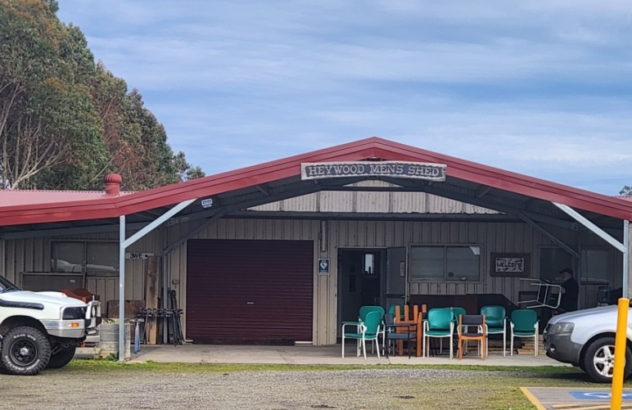
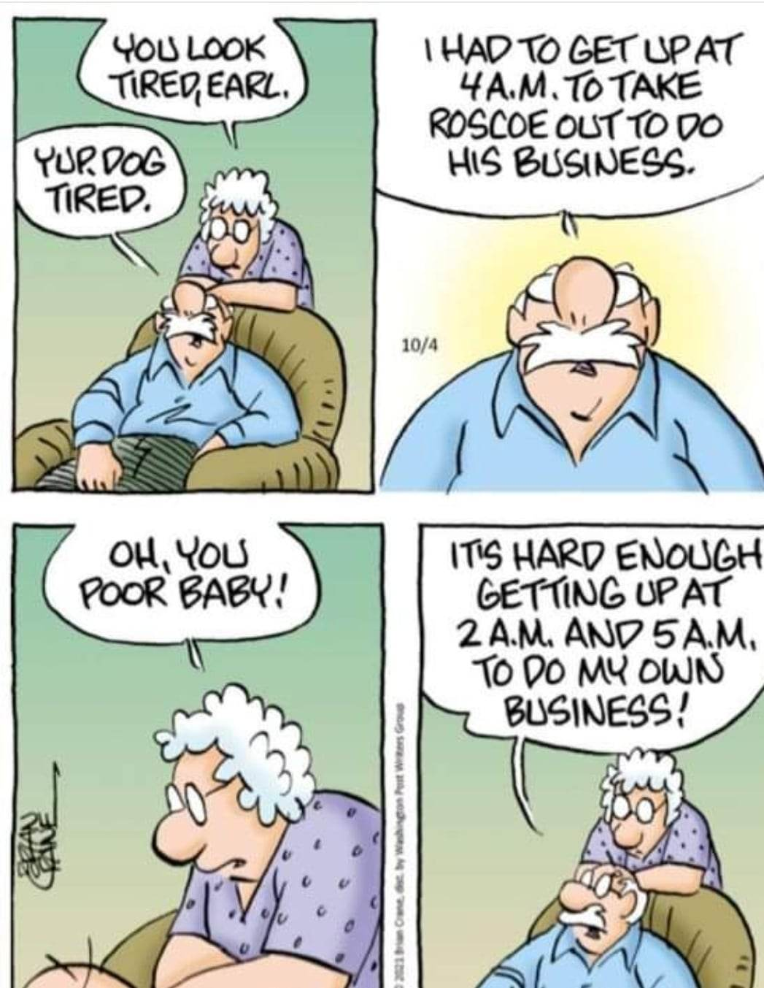
SPONSORS

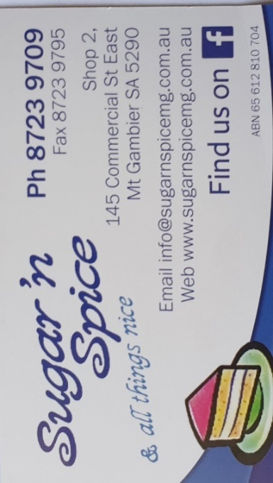






Big supporters of Mount Gambier Mens Shed

SUPPORT OUR LOCAL BUSINESSES
THAT SUPPORT YOU
Son: Dad, I want to marry
Dad: Say Sorry
Son: For what?
Dad: Say Sorry
Son: But for what?
Dad: You first say Sorry
Son: But what’s my fault?
Dad: You first say Sorry
Son: At least tell me the reason
Dad: First say sorry
Son: Ok Dad! I’m sorry
Dad: Now you are ready for marriage my son.
Your training is complete. You’ve learned to say sorry without any reason.

