EXECUTIVE MEMBERS FOR 2023
PRESIDENT: Ian Bond 0420859540
VICE PRESIDENT: Grant Sullivan
TREASURER: John Plunkett
SECRETARY: Paul Edgeworth 0497386846

PHONE: 0478614027 (prefer Tuesday and Thursday am)
Open Tuesday, Wednesday & Thursday 9am– 12pm 1a McDonnell Drive

Website www.mgmensshed.com.au
Facebook Mens Shed Mount Gambier
Email mgmensshed@gmail.com

BIRTHDAYS
Alan R 11/11
Grant S 17/11
Geoff H 19/11
Graham R 21/11
Dale A 24/11
Bert S 27/11
Graham T 28/11

CALENDAR - November
Wednesday 8th 6.30pm Shedder& partners tea
at Jens Hotel, 40 Commercial Street East
Thursday 9th 10.30am Members Meeting
Tuesday 28th 10.30am Committee Meeting
Thursday 30th 11.30am BBQ lunch with partners
for Barry Day

If you would like to contribute information or an article to your newsletter, talk to Editor David N or email mgmensshed@gmail.com

Our thoughts are with Russell Smith on the death of his brother late last month.

10. Block Plane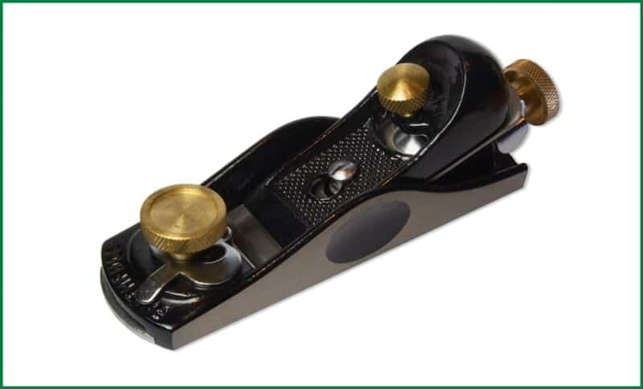
A block plane is a wooden device made for manual use. It has a blade embedded in the bottom of the wooden frame. The blade is like a chisel that consists of the bevel on one side and plane on the other. In a typical block plane, the bevel side remains up leaving the flat part on the down. The angles must be tuned properly to make necessary cuts. The ergonomic structure makes it very handy to use.

Uses of Block Plane
The block planes are used for giving a finishing touch to the completed work. It can cut end grains to give a smooth finish. With this tool, shallow cuts can be made having smaller angles.


Advance notice – planning so far
MENS SHED CLUSTER
HEALTH and INFORMATION DAY
THURSDAY 16TH MAY 2024
10am to 3pm (SA time)
A SHED SHARING FORUM
SPEAKERS:
MATTIAS WICHMANN (MD) –- a light hearted and informative session about ‘gut health and issues’

IAN LEWIS – the only cave diving, hydrogeologist in Australia
Illustrated topics include–a fascinating expose on the unique geological formations in SW Victoria and the SE South Australia: fault lines, volcanoes, caves, sinkholes

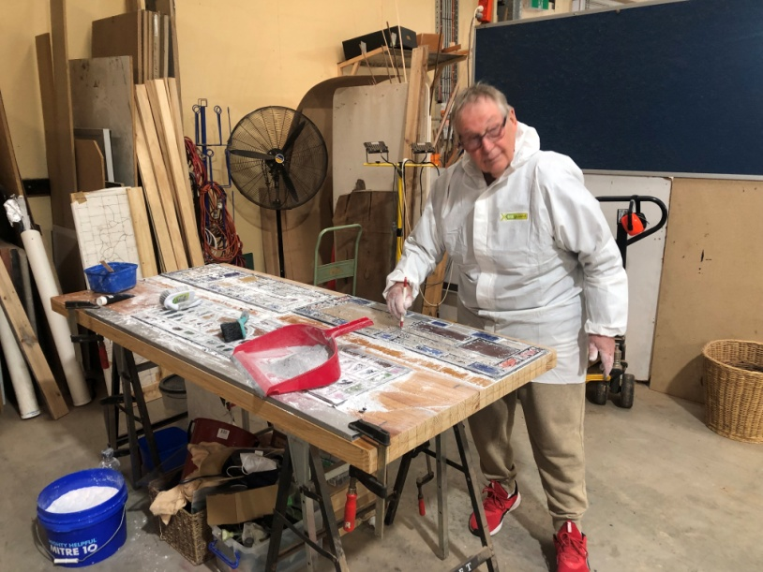
Graham preparing leadlight glass above
Finished project below
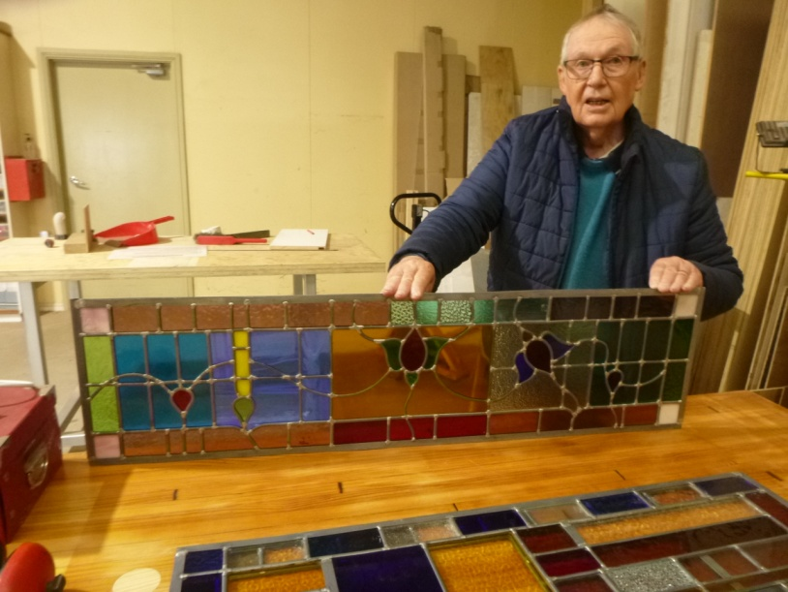

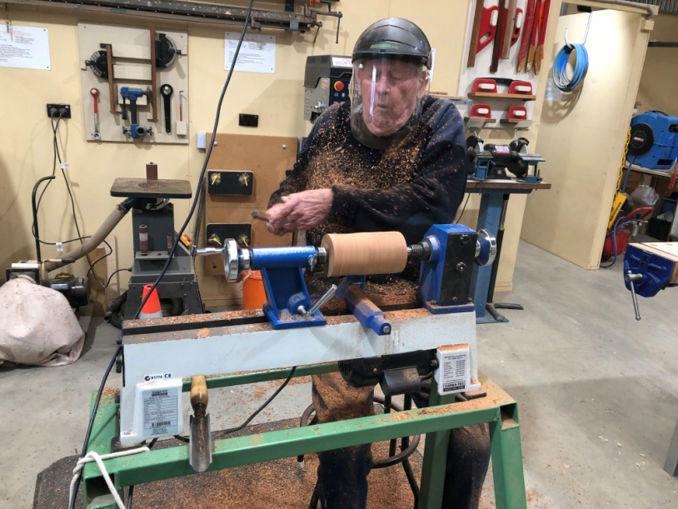
Ian covered in woodchips at the lathe
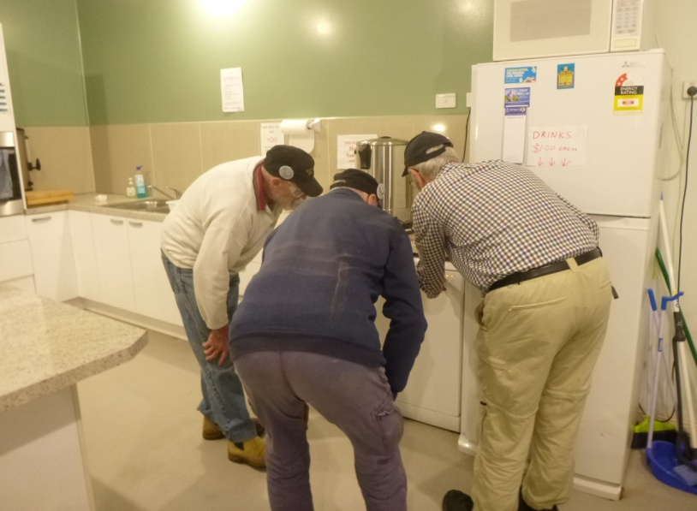
Frank, Don & Graham - How do you start a dishwasher?

Recently the Mount Gambier Men’s Shed donated $300 to the local South East Prostate Cancer Support Group as part of the Prostate Awareness week.
Vice President Grant Sullivan handed over the cheque to Southeast Prostate Support Group representatives Richard Harry and Brian Hueppauff. The Mount Gambier Shed decided to make this gesture as they support men’s health initiatives and this is one close to their hearts.
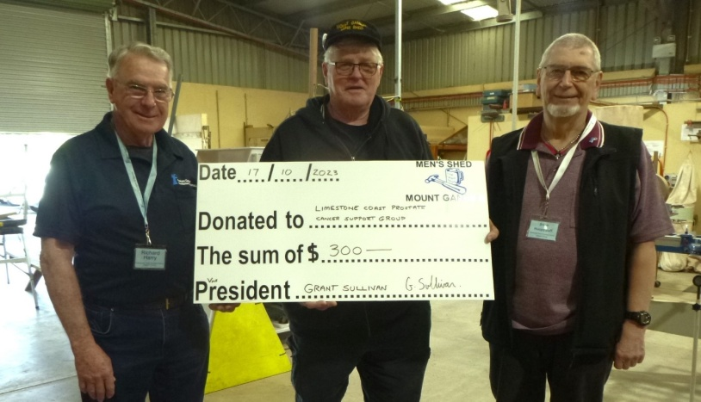
When life gives you lemons . . .
make an easy Lemon Slice
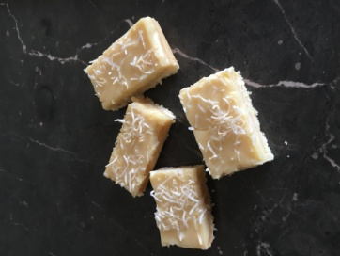
Grease and line an 18cm x 28cm rectangular slice pan.
Preheat oven to 160oC fan forced or 180oC

Mix together 340g packet vanilla cake mix, 1 cup coconut, 125g melted butter and zest of 1 lemon. Press over base of prepared pan. Bake for 10 minutes. Remove from oven and cool for 10 minutes. Stir 2/3 cup lemon juice into 395g can of condensed milk. Spread over base. Sprinkle with extra coconut. Bake 15 minutes or until filling has set. Cool, refrigerate for 3 hours.
Cut into rectangles. Editor’s note - Delicious

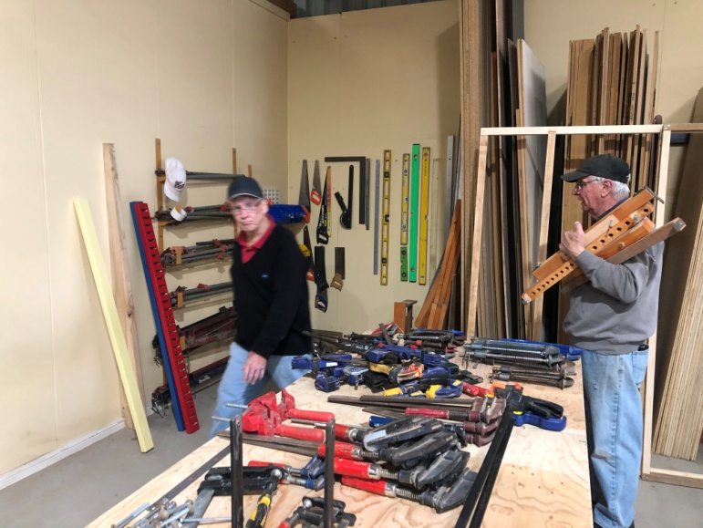
Tim & Geoff reorganising the clamps

If you’re ever worried that a woodworker might be going insane,
just ask him if he has too many clamps.
If he says yes, get help immediately.

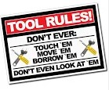

The journey of a thousand miles . . . begins with a broken fan belt and a flat tyre.

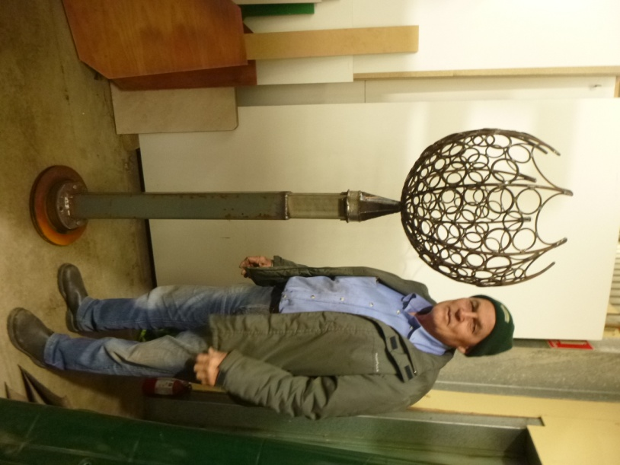
Trevor’s finished garden feature made from recycled metals
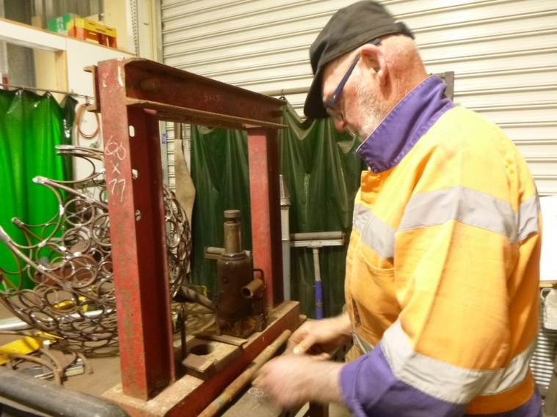
Bruce constructing a hydraulic press
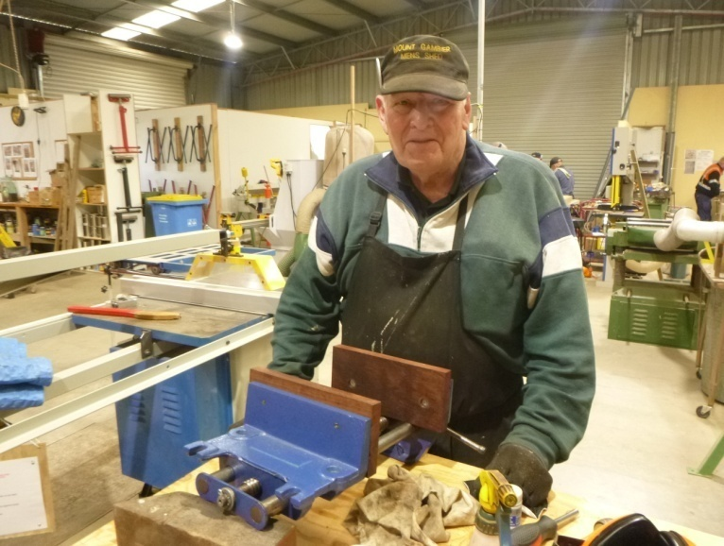
Alan fitting modified vices to new benches
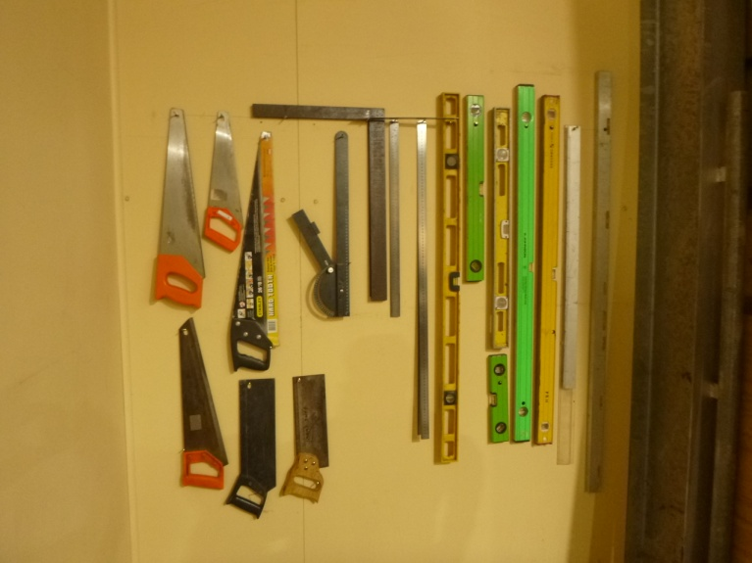
Utilising space better – a shadow board made by Geoff

Peter asked his granddaughter to pass him the newspaper.
“Oh, come on, Grandpa,” she said. “Nobody reads print anymore. Here, just use my laptop.”
He shrugged.
The fly on the workbench never saw it coming.

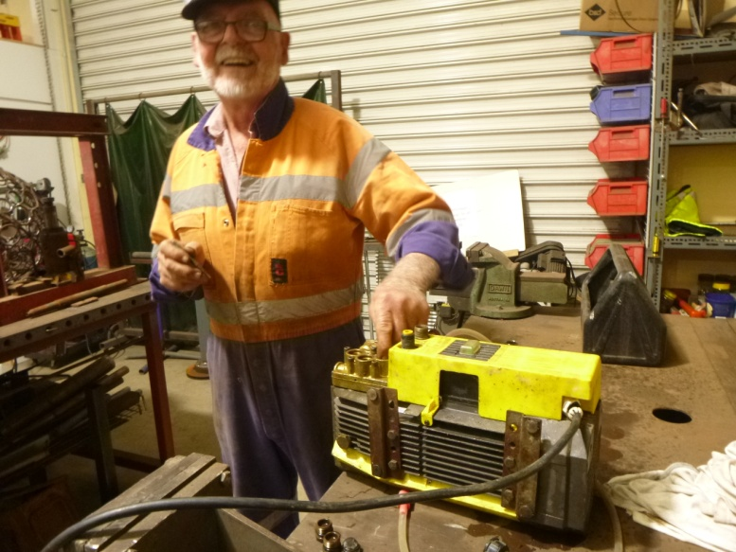
Bruce repairing an electric pump


SPONSORS











Big supporters of Mount Gambier Mens Shed
SUPPORT OUR LOCAL BUSINESSES
THAT SUPPORT YOU

